Rebuilding the Old Tyne Bridge:
The Victorians’ relationship with their medieval heritage
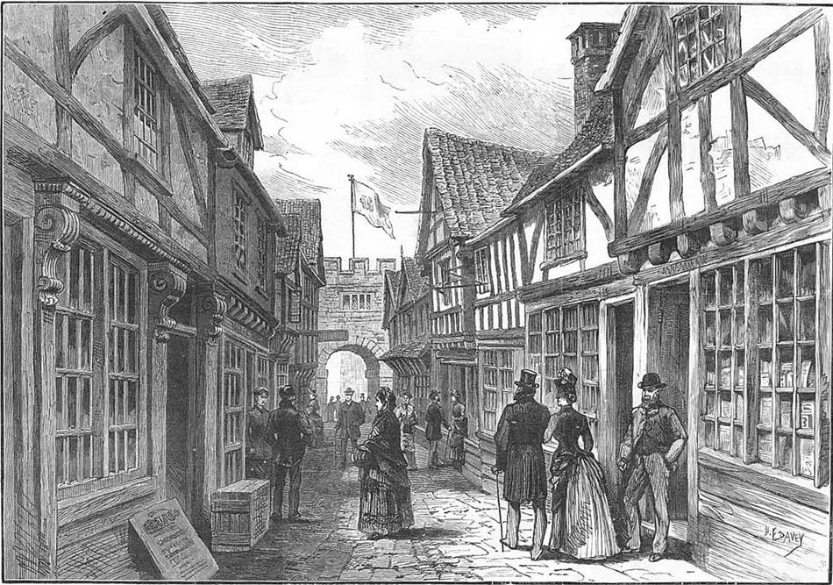

Joshua Howlett and Louis Lorenzo Holland Bonnett



An important aspect of how a civilisation defines its own identity rests on how it perceives its own history. In this article, we are looking at one aspect of how a society can use the past as a resource to justify and explain present and future. Specifically, we investigate the Victorians’ well documented fascination with the ‘Middle Ages’, which often appears to consist of an ambivalent mixture of admiration and revulsion toward the period, through a specific local example, the reconstruction of the 13th century ‘Old Tyne Bridge’ in Newcastle for the ‘Jubilee Exhibition’ of 1887.
This exhibition, often mistaken for the better known 1929 ‘North-East Coast Exhibition’ was arranged by the ‘The North-East of England Institute of Mining and Mechanical Engineers’ and was designed to promote local enterprise and industry. The exhibition was due to open in 1886 but it was decided to defer the occasion for a year to allow it to coincide with queen Victoria’s golden jubilee. The name was therefore changed from the ‘Mining, Engineering and Industrial Exhibition’ to the ‘Jubilee Exhibition’. The exhibition opened on the 11th of May 1887 and through its 7-month lifespan attracted over two million visitors from home and abroad. The reconstructed medieval bridge, which had crossed the Tyne until it was washed away by ‘the flood’ of 1771, was one of the central attractions. The bridge might easily be mistaken for the famous old London bridge, with buildings across its span, but the rebuilt bridge became a symbol of pride for North-East England. It also symbolised an intriguing Victorian engagement with its pre-industrial past during a period of industrial modernity. This article offers an account of the bridge, and what it meant to the Victorian people.
The Victorian narrative of the Middle Ages was not cohesive, but highlighted several contrasting aspects and viewpoints of it. On the one hand, the medieval period was sometimes portrayed as ‘dark’ and primitive; a time of regression and backwardness brought about by the fall of the Western Roman Empire in the 5th century; a period whose problems were remedied with the arrival of the renaissance in the 14th century. However, based on our research on the recreation of the 13th century Tyne Bridge for the 1887 Jubilee exhibition, we add to the literature that argues that the more influential perspective was one of a positive and engaged attitude toward the period. This attitude constructed the medieval period as an era of racial vigour, natural beauty and purity, and also of industry; a foreshadowing of the Victorian’s vision of themselves.
Our case study of the Old Tyne Bridge will not attempt to cover all aspects of the wide-ranging nature of medieval revivalism but focus, instead, on one particular aspect; that is, the physical reconstruction of a place. This is a separate pursuit from looking at Victorian literature that sought to romantically conjure the Middle Ages. Creating a physical replica is not merely an attempt to reflect on the past, but a bold claim to be able to emulate and reconstruct it. Discovering exactly in what manner and why this past was emulated and re-built will help us deepen our knowledge of the nature and range of Victorian ‘medievalism’.
However, before we turn to our case study we need first to understand the two periods which we are discussing to discern exactly why the Victorians would want to build this bridge. What links, and what divides, the 13th and 19th centuries? On face value, it seems logical that the Victorians would be as dismissive of the medieval period as their Georgian predecessors were, who saw themselves living in total juxtaposition to the people of the ‘dark ages’. For the Georgians, they lived in an ‘age of reason’ which needed to draw no lessons from the ‘age of faith’, terms coined by Thomas Paine ninety-three years prior to the 1887 exhibition. Such notions were propounded by many forefront Georgian intellectuals, establishing an image of an advanced and sophisticated society which defined itself against the ‘Dark’ and Middles Ages.
However, many Victorians did not take this view of their pre-enlightenment past and they increasingly portrayed the Middle Ages as a period which contained many echoes of their own predicaments and possibilities. This was not just romantic nostalgia; it reflected the existence of real parallels. For example, both periods were ones of change and large-scale migration and exploration, the best Dark Age and early medieval examples being those of the migration of Vikings into Northern Europe and the Normans into England, as well wider movements across Europe such as the movement of German peoples into eastern Europe. The Victorian period saw migration of colonising Europeans into Africa, America, and Asia. The Victorians found in the Middle Ages a historical rationale and pretext for their own imperialism and saw a reflection of their own militaristic tendencies in the campaigns, conquests and crusades of both the early Middle Ages and the 12th and 13th centuries. Indeed, it was largely during the Victorian period that military figures such as Richard the Lionheart and ‘Alfred the Great’ were venerated, and fashioned as popular and patriotic figures. These were heroes to be placed alongside contemporary characters such as the Generals Gordon and Kitchener. In both societies, the nobility was heavily involved in military expansion and although Victorian society was post-feudal, members of the landed aristocracy often imagined themselves as heirs to ancient tradition and were heavily involved in local and national government as well as imperial policy. Thus, many Victorians venerated their medieval ancestors, both because the two societies appeared to contain certain similarities but also because the Victorians found the medieval past a useful place to construct origin narratives; narratives that explained their own pre-eminence.
Many Victorian historians propagated a nostalgic relationship to the medieval period. History Professors Charles Kingsley and J R Seeley, both of Cambridge University, wrote and talked about the ‘Dark Ages’ and ‘Middle Ages’ as a period of valour, achievement and of inspiration. Kingsley spoke about the need to revert back to “Teutonic traditions”, and Seeley, in his 1883 text, ‘The Expansion of England’ claimed that the British empire was grounded in and bound by ancient bonds of blood and religion. Furthermore, politicians in the Victorian period often evoked these earlier periods in order to shape and excite the popular mood. For example, Sir Charles Adderley who made use of the increasingly popular notion of an ‘Anglo-Saxon race’ to argue in a speech given in Warwickshire; that “The Anglo-Saxon race are the best breed in the world, the absence of a too elevating climate, too unclouded skies and a too luxurious nature, has produced so vigorous a race of people, and had rendered us so superior to all the world”. Here we see the past being mobilised to serve the present. Joseph Chamberlain, a leading liberal imperialist politician by the late Victorian period, also emphasised the superiority of the “Anglo-Saxon Race”. Partly then, it can be argued that the reconstruction and civic use of medieval architecture, culture, and design, such as with the old Tyne bridge, was a visible and tangible reflection of the Victorians’ historical claims upon the supposed accomplishments and vigour of the ‘Anglo-Saxons’.
But the bridge was not a singularity of this ‘reconstructive nostalgia’ for the Middle Ages. Across Britain, Victorian architecture reflected medieval influences. The ‘neo-gothic’ and gothic revival movements stamped themselves on almost every city. Inspired by the architecture and decorative art of the period 1000-1600CE, such neo-medieval forms became a significant alternative to classical styles. Indeed, the word ‘gothic’ itself was an invention of the late 18th century, its more thrillingly macabre connotations being popularised in the 19th century through texts such as ‘Frankenstein’ (1818), ‘The Fall of the House of Usher’ (1839), and ‘Dracula’ (1897). Britain embraced the gothic, more than any other European country, because of its desire to reclaim a shared and lost past of vigour, beauty and industry but also because of its fears of ethical and racial degeneration. Strawberry Hill, home of Horace Walpole, a major participant in the medieval revival, as well as Fonthill Abbey are two of the most influential examples of this style. Windsor Castle also provides a good example of how late medieval and early Gothic architecture influenced the Victorian period. Between 1824 and 1840 Sir Jeffrey Wyattville transformed Windsor: adding turrets, towers, battlements, and raising the height of its round tower in order to emulate the medieval. The Gothic was the cultural zeitgeist of the time and the rebuilding of the old Tyne bridge for the 1887 exhibition was an attempt to capture that public mood, as had been done in other cities across the country beforehand such as with the ‘Old London’ exhibition of 1885 and ‘Old Edinburgh’ of 1886. There was a sense that the exhibition, which opened on the 11th of May 1887, was an opportunity for Newcastle to advertise itself to the rest of the country and assert its cultural and economic prestige. The neo-gothic bridge was, in part, an attempt to show visitors that Newcastle had an interesting and rich history that stood alongside cities like London and Edinburgh. The Victorians clearly made a connection between the bridge and the gothic as they were particularly interested in how the bridge was used to display severed heads, and, famously, the right arm of William Wallace in 1305.
Taken at first glance, the placement of the recreated Tyne bridge at the centre of the Jubilee Exhibition seems incongruous. Its old-fashioned style clashes with the overall theme of the exhibition that was designed to showcase the modern engineering and technological wonders of the North-East. Local inventors such as William George Armstrong and Joseph Wilson Swan were placed prominently, as well as names associated with George Stephenson. Indeed, the Exhibition had originally been planned to be called the “Royal Mining Engineering and Technological Exhibition”, only changing its name to coincide with Queen Victoria’s Golden Jubilee. Ostensibly, it had nothing to do with medievalism or history. Yet, in the midst of the technological and engineering wonders, such as Armstrong’s 111ton Elswick gun, the rebuilt 13th century Tyne Bridge was centre-stage, a 600-year-old mock relic. We have already identified some of the motives behind the reconstruction; an attempt to appropriate the gothic zeitgeist, to recapture an idealised lost past, and to exhibit the accomplishments of Newcastle and the North-East to the rest of the country, and indeed, the world.
Additionally, the bridge could have represented an entrepreneurial work ethic which the Victorians held in high esteem. Newcastle is built around its river, and to the Victorians the medieval bridge represented a practical, business-friendly crossing, factors which they saw as absent from the much plainer Georgian design which replaced it. The 13th century bridge had high arches which allowed cargo ships to pass whereas the Georgian bridge was too flat and low for that purpose. The medieval bridge also served for commercial use by having shops and houses built directly upon it. This appealed to Victorian entrepreneurialism and sentimentality and were aspects keenly replicated for the duplicate version. Perhaps the Victorians’ demolition, in 1868, of the Georgian bridge in favour of the swing bridge (which, as the name suggests, could turn on its axis to enable ships to pass) felt like a return to a time when the Tyne was a ‘working river’. If we look at how accurately they reconstructed the old bridge and how strictly rules were enforced to maintain authenticity it is logical to conclude that the Victorians were attempting (whether they were successful or not) a faithful recreation, not a caricature, of the medieval style.
The chief architect of the reproduction was Mr. Philip John Messent who was completing the design for ‘The North-East of England Institute of Mining and Mechanical Engineers’. Messent used multiple sources as reference to his design including maps, etchings, and engineer’s reports in order to keep his replica as close to his available source material as possible. The only prepared difference was the making of the bridge one third shorter (but keeping all other dimensions, including width, the same). This is in stark contrast to the bridge built in the same location for the 1929 ‘North-East Coast Exhibition’, which followed a distinctly modern art-deco form and, hence, was fully in-keeping with the overall style of the exhibition. That bridge simply crossed the pond at the narrowest point whereas the 1887 bridge ran diagonally across the water to give the bridge a greater size and stature. The function of these two crossings was clearly very different, the 1887 bridge was not built simply ‘to get to the other side’ but was instead engineered to be a source of excitement and inspiration.
The Victorians utilised their medieval past to act as a reflection of their own identity and achievements. The reconstructed Tyne bridge is a unique example of how they achieved that. The context in which it was built, of an industrial exhibition, reveals the relation the Victorians drew between their past and future. However, although this link could have easily been a fabricated one, as it is in many cases, for this instance the connection is wholly appropriate. The Victorians did not need to raise the arches or populate the structure with businesses of the old Tyne bridge because, for them, history had manufactured a historical precedent all for itself.
Joshua Howlett and Louis Lorenzo

Bibliography
Barczewski, Stephanie L. Myth and National Identity in Nineteenth Century Britain: The Legends of King Arthur and Robin Hood. Oxford; New York: Oxford University Press, 2000.
Crook, Paul. Social Darwinism and British New Imperialism: Second Thoughts. Oxford: Routledge, 1998, 2-3.
Evans, Richard. “The Victorians: Empire and Race”. Lecture presented at Gresham College, London, 11th April 2011.
Frayling, Christopher. Vampyres: Lord Byron to Count Dracula. London: Faber, 1991.
Gibbon, Edward. The History of the Decline and Fall of the Roman Empire. London: Strahan & Cadell, 1776-1789.
Härke, Heinrich. "Anglo-Saxon Immigration and Ethnogenesis." Medieval Archaeology 55, 2011.
Higham, Nicholas J and Ryan, Martin J. The Anglo-Saxon World. New Haven: Yale University Press, 2nd Oct. 2015.
Mommsen, Theodore. Petrarch's Conception of the 'Dark Ages'. Cambridge: Speculum, 1942.
Paine, Thomas. The Age of Reason; Being an Investigation of True and Fabulous Theology. London: Self Published, 1794.
Roberts, Helene E. "Victorian Medievalism: Revival or Masquerade?" Browning Institute Studies 8 (1980): 11-44.
Seeley, John Robert. The Expansion of England: Two Courses of Lectures. Adamant Media Corporation, 28th September 2001, 1-156.
Victoria and Albert Museum. “Style Guide Gothic Revival.” Accessed 20th August 2017. http://www.vam.ac.uk/content/articles/s/style-guide-gothic-revival.

Primary Source Material
Source A)
Location: Tyne and Wear Archives, Discovery Museum, Newcastle-upon-Tyne
Title: Illustrated article reprinted from the “Newcastle Daily Journal 1886” and headed ‘Newcastle Jubilee Exhibition’, concerning the history of the Old Tyne Bridge.
Reference Number: DX95/3
Date: 13th of November 1886
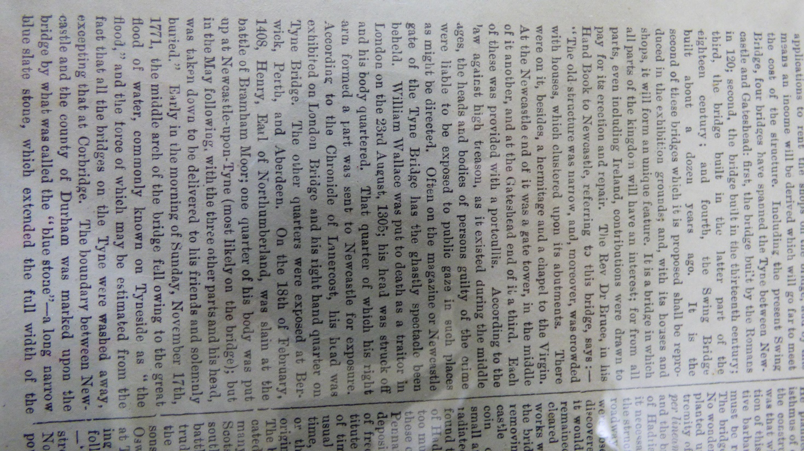
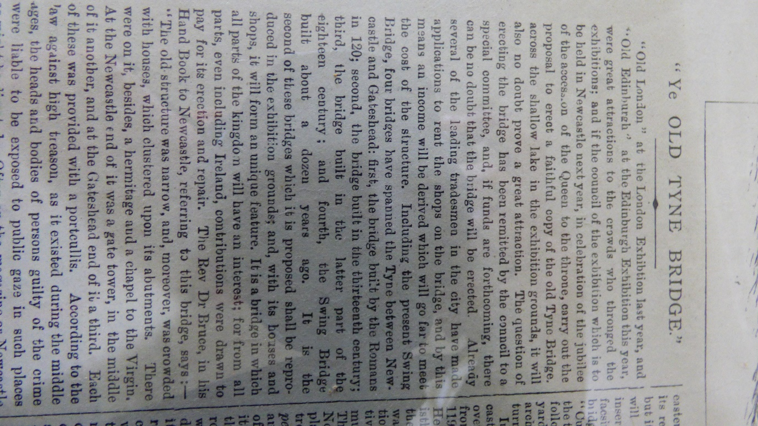

Source B)
Location: Literary and Philosophical Society of Newcastle-upon-Tyne
Title: Folder of plans and illustrations
Shelfmark: Literary & Philosophical Society Bolbec OSFOLIOWALL N042/7
Section: The Graphic Newcastle-on-Tyne
Date: 4th of June 1881
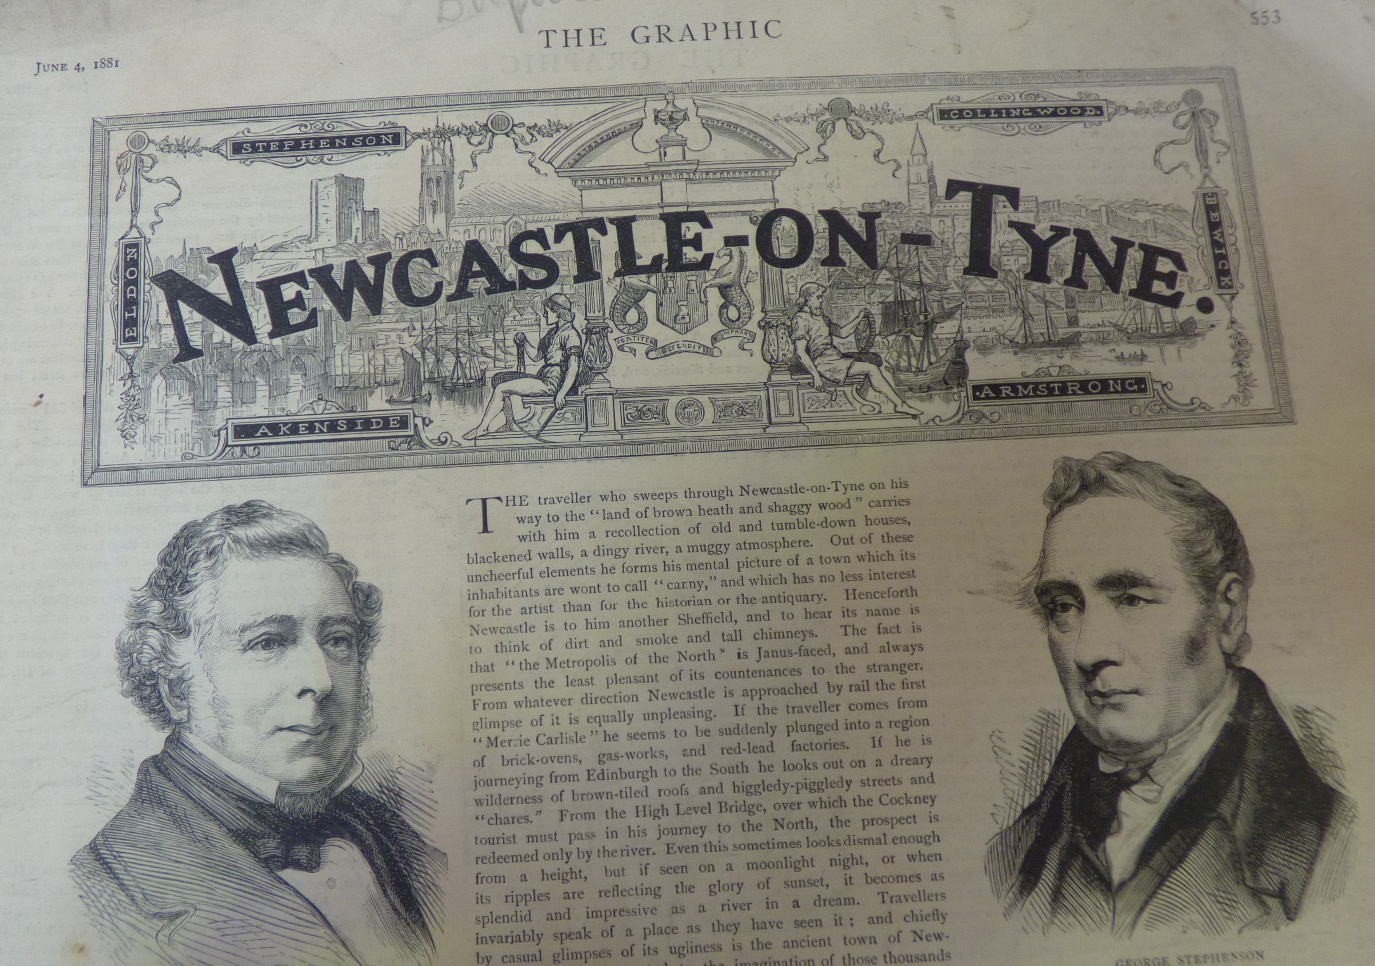

Source C)
Location: Literary and Philosophical Society of Newcastle-upon-Tyne
Title: Illustrated catalogue of the photographs on view in the Newcastle Jubilee Exhibition, under the auspices of the Newcastle-upon-Tyne and Northern Counties Photographic Association.
Shelfmark: Literary & Philosophical Society Librarian's Room LOCAL N606/3
Section: Opening Plans and descriptions at start of text
Date: 1887 (Presumably May, the month in which the exhibition was opened)
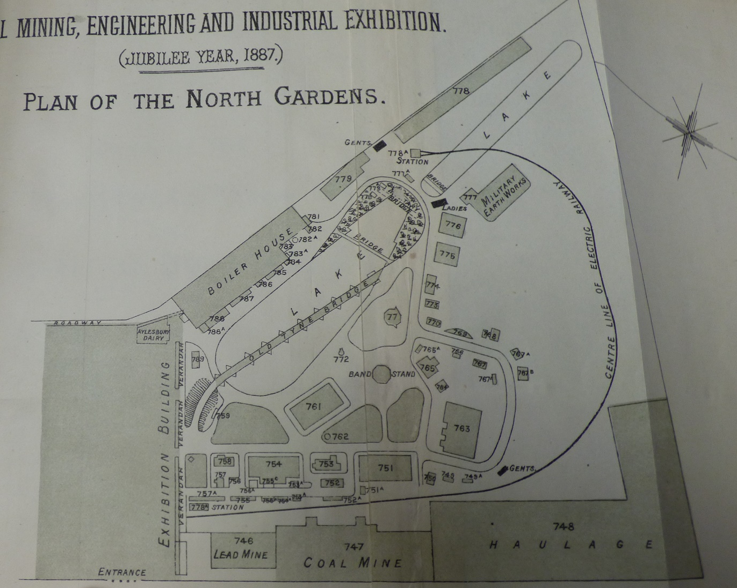

Source D)
Location: Literary and Philosophical Society of Newcastle-upon-Tyne
Title: Illustrated catalogue of the photographs on view in the Newcastle Jubilee Exhibition, under the auspices of the Newcastle-upon-Tyne and Northern Counties Photographic Association.
Shelfmark: Literary & Philosophical Society Librarian's Room LOCAL N606/3
Section: List of patrons, executive staff and shopkeepers at exhibition in middle of text.
Date: 1887 (Presumably May, the month in which the exhibition was opened)

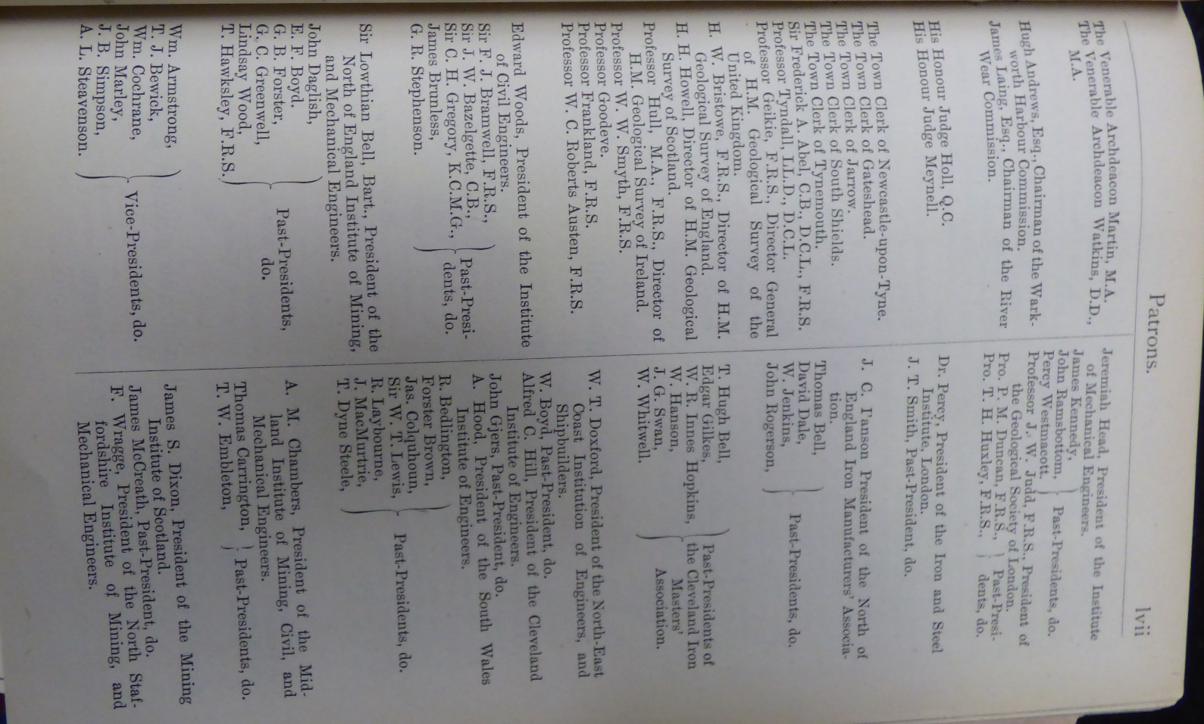

Source E)
Location: Literary and Philosophical Society of Newcastle-upon-Tyne
Title: Illustrated catalogue of the photographs on view in the Newcastle Jubilee Exhibition, under the auspices of the Newcastle-upon-Tyne and Northern Counties Photographic Association.
Shelfmark: Literary & Philosophical Society Librarian's Room LOCAL N606/3
Section: List of patrons, executive staff and shopkeepers at exhibition in middle of text.
Date: 1887 (Presumably May, the month in which the exhibition was opened)
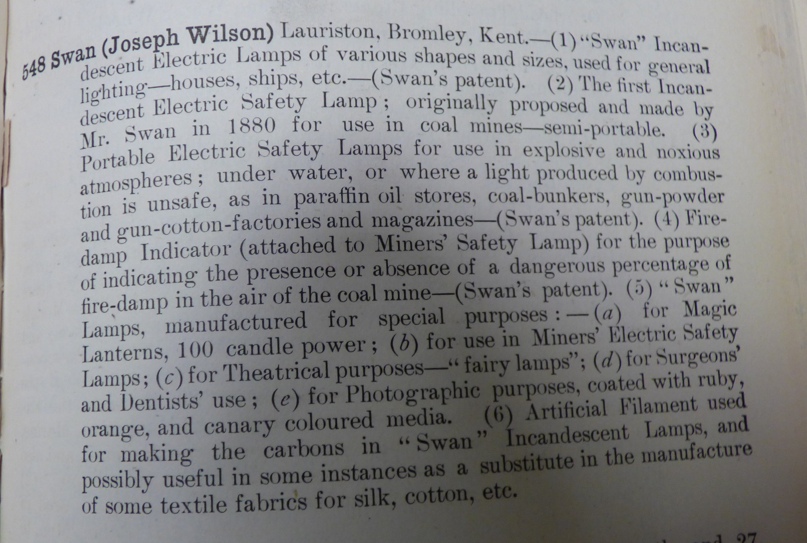

Source F)
Location: Literary and Philosophical Society of Newcastle-upon-Tyne
Title: The bridges and the floods of Newcastle-upon-Tyne
Shelfmark: Literary & Philosophical Society Bolbec LOCAL N042/5 (9)
Date: 1887

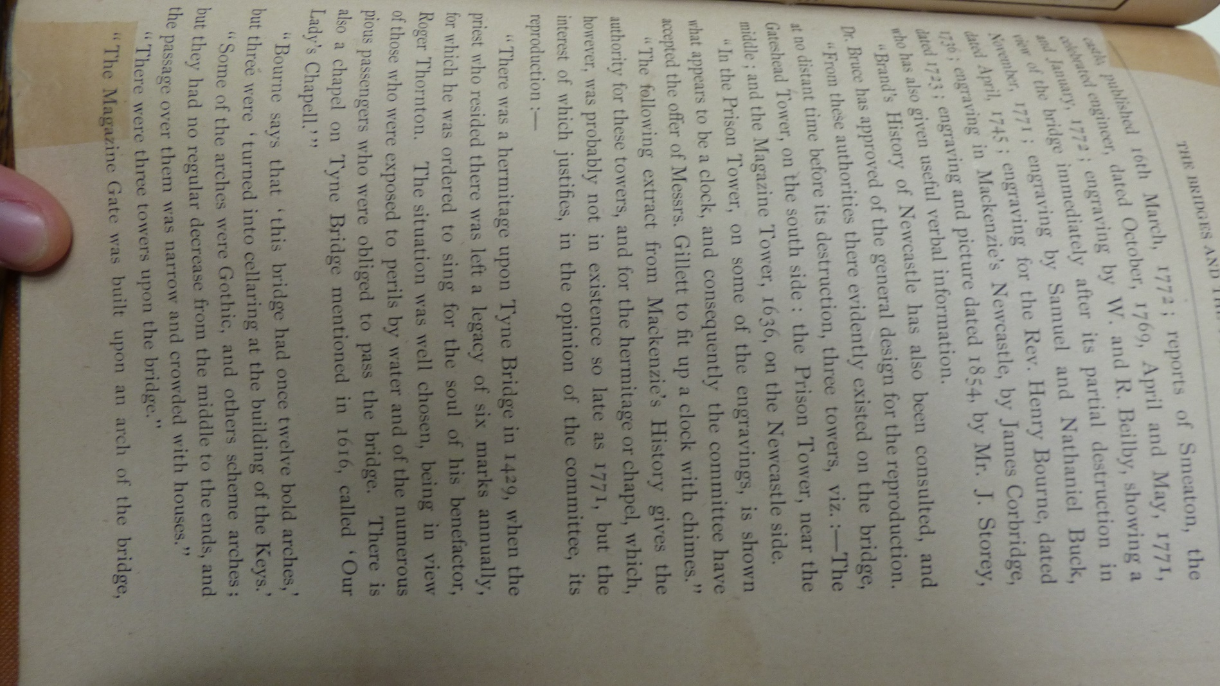

Source G)
Title: Illustrated catalogue of the photographs on view in the Newcastle Jubilee Exhibition, under the auspices of the Newcastle-upon-Tyne and Northern Counties Photographic Association.
Shelfmark: Literary & Philosophical Society Librarian's Room LOCAL N606/3
Section: Regulations and rules for exhibitors and visitors at start of text.
Date: 1887 (Presumably May, the month in which the exhibition was opened)
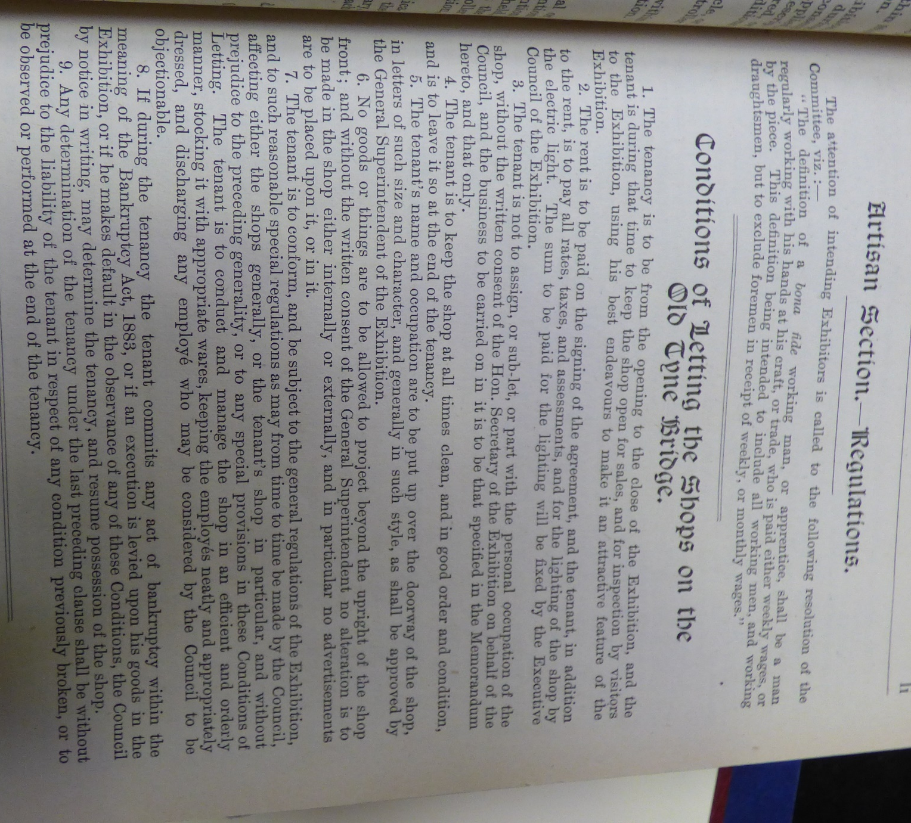

Source H)
Title: Illustrated catalogue of the photographs on view in the Newcastle Jubilee Exhibition, under the auspices of the Newcastle-upon-Tyne and Northern Counties Photographic Association.
Shelfmark: Literary & Philosophical Society Librarian's Room LOCAL N606/3
Section: Regulations and rules for exhibitors and visitors at start of text.
Date: 1887 (Presumably May, the month in which the exhibition was opened)
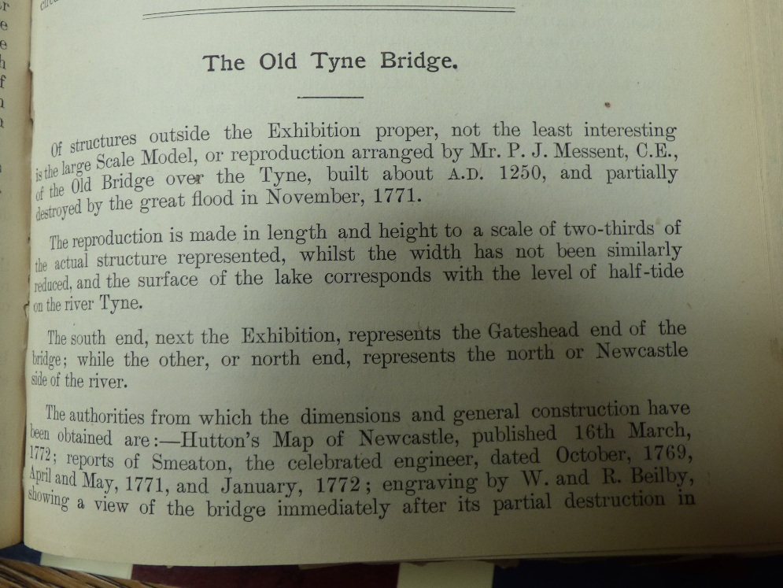

Source I)
Location: Literary and Philosophical Society of Newcastle-upon-Tyne
Title: The bridges and the floods of Newcastle-upon-Tyne
Shelfmark: Literary & Philosophical Society Bolbec LOCAL N042/5 (9)
Date: 1887

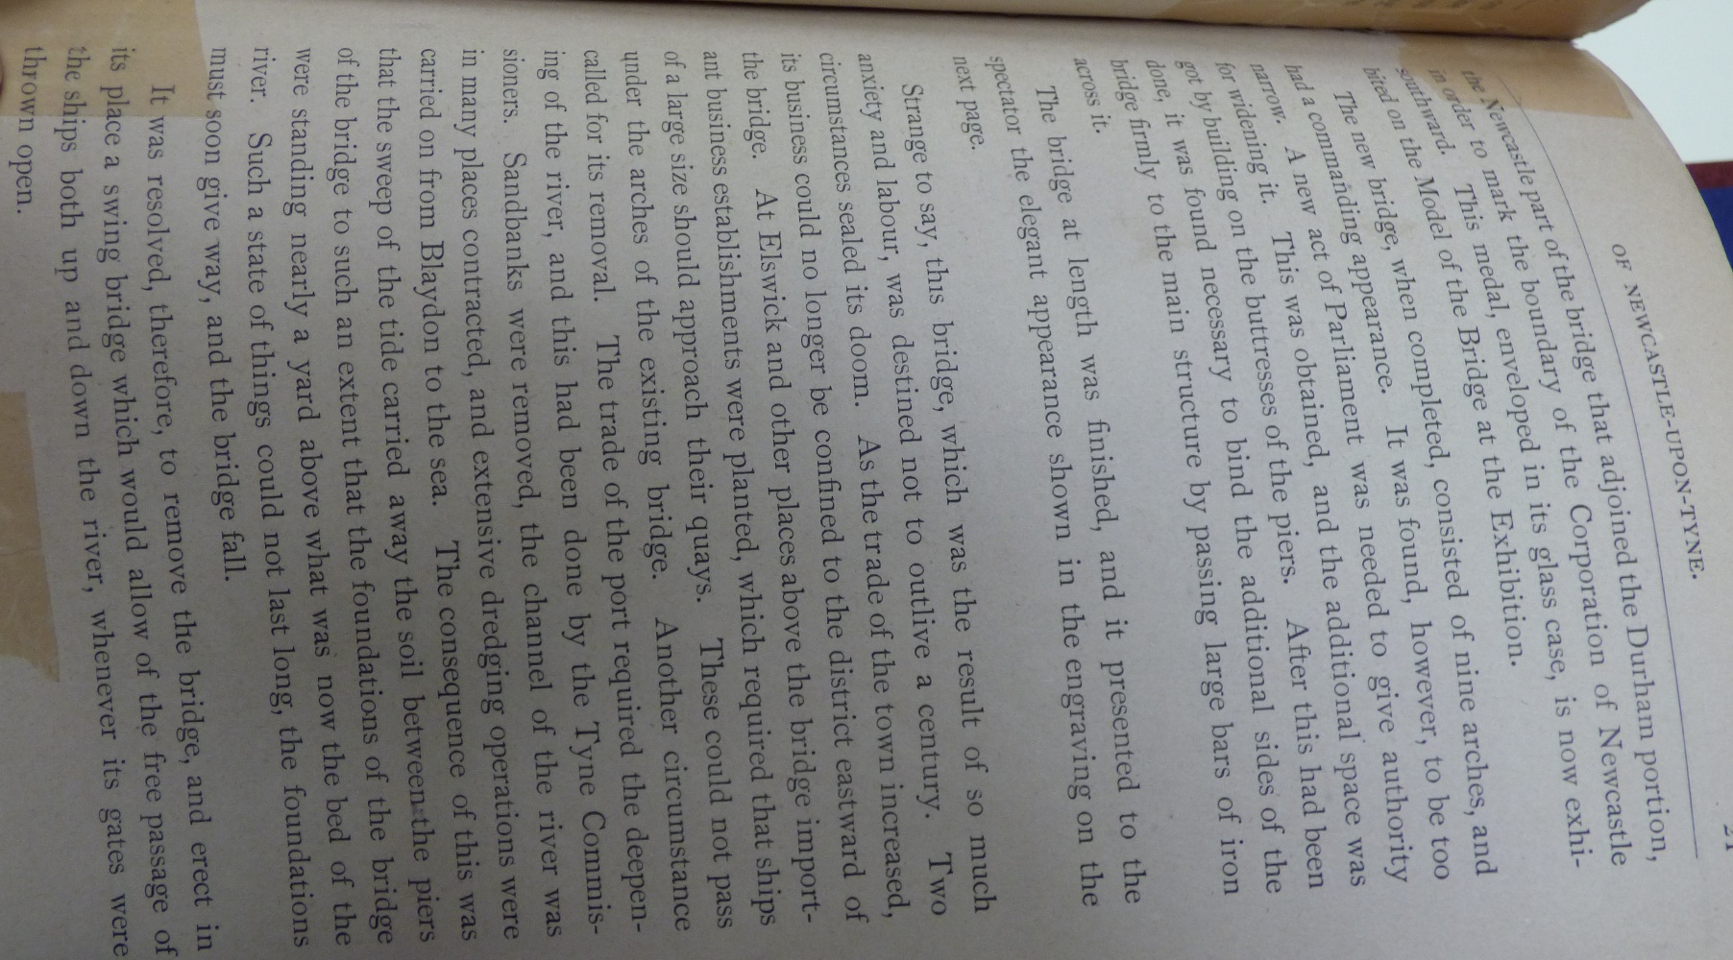

Source J)
Location: Tyne and Wear Archives, Discovery Museum, Newcastle-upon-Tyne
Title: Diary of William Dunn including references to Queen Victoria's Golden Jubilee exhibition, political and social life in Newcastle etc.
Reference Number: DX225/1
Date: 1887

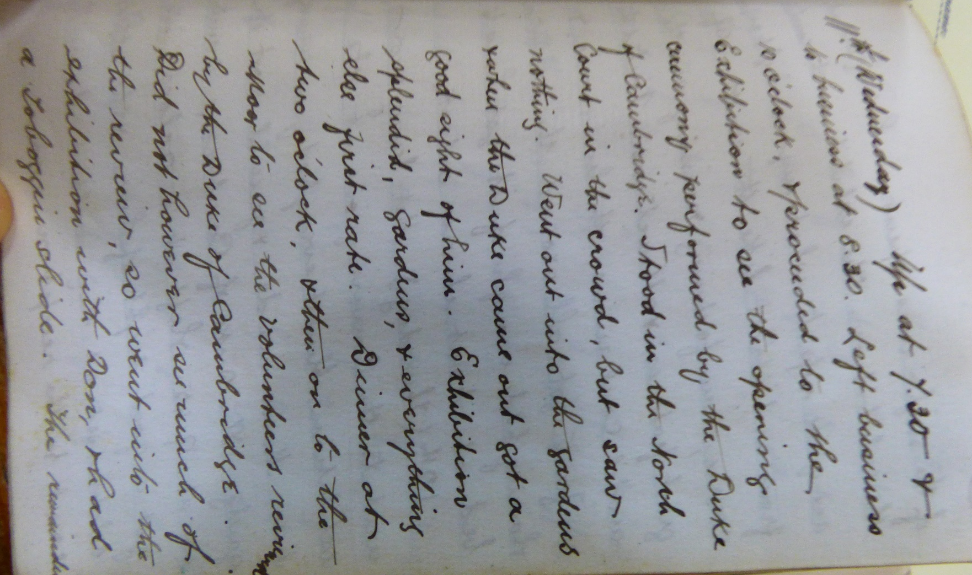

Source K)
Location: The North-East of England Institute of Mining and Mechanical Engineers
Title: Proceedings. President’s address at the annual general meeting, held at The North-East of England Institute of Mining and Mechanical Engineers
Date: August 1886

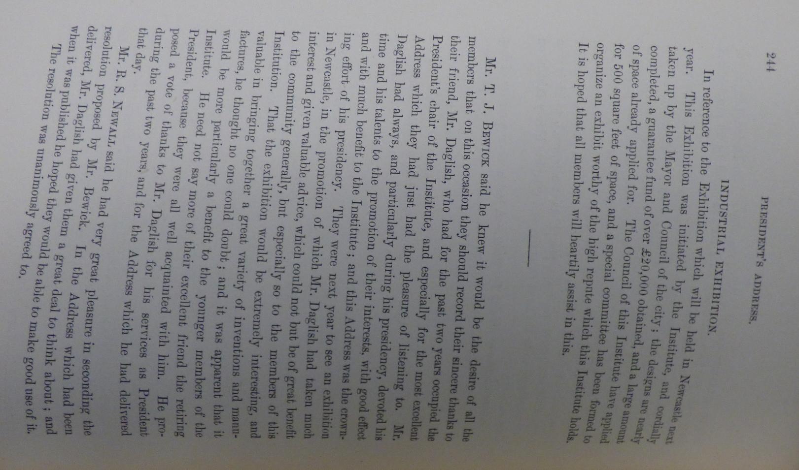

Source L)
Location: Newcastle City Library
Title: The Bridge, North-East Coast Exhibition 1929, Newcastle-upon-Tyne
Object: Postcard
Date: 1929
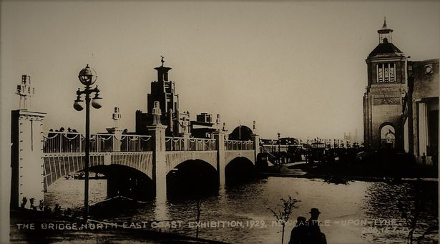

Bibliography
Barczewski, Stephanie L. Myth and National Identity in Nineteenth Century Britain: The Legends of King Arthur and Robin Hood. Oxford; New York: Oxford University Press, 2000.
Bartlett, Robert. “Introduction: Perspectives on the Medieval World." Medieval Panorama, 2001.
Crook, Paul. Social Darwinism and British New Imperialism: Second Thoughts. Oxford: Routledge, 1998, 2-3.
Evans, Richard. “The Victorians: Empire and Race”. Lecture presented at Gresham College, London, 11th April 2011.
Frayling, Christopher. Vampyres: Lord Byron to Count Dracula. London: Faber, 1991.
Gibbon, Edward. The History of the Decline and Fall of the Roman Empire. London: Strahan & Cadell, 1776-1789.
Härke, Heinrich. "Anglo-Saxon Immigration and Ethnogenesis." Medieval Archaeology 55, 2011.
Higham, Nicholas J and Ryan, Martin J. The Anglo-Saxon World. New Haven: Yale University Press, 2nd Oct. 2015.
Mommsen, Theodore. Petrarch's Conception of the 'Dark Ages'. Cambridge: Speculum, 1942.
Paine, Thomas. The Age of Reason; Being an Investigation of True and Fabulous Theology. London: Self Published, 1794.
Roberts, Helene E. "Victorian Medievalism: Revival or Masquerade?" Browning Institute Studies 8 (1980): 11-44.
Seeley, John Robert. The Expansion of England: Two Courses of Lectures. Adamant Media Corporation, 28th September 2001, 1-156.
Victoria and Albert Museum. “Style Guide Gothic Revival.” Accessed 20th August 2017. http://www.vam.ac.uk/content/articles/s/style-guide-gothic-revival.

This view first expressed by Petrarch in the 1330s who was particularly concerned with the loss and corruption of language which had occurred since the 5th century. For more see: Theodore Mommsen, Petrarch's Conception of the 'Dark Ages' (Cambridge: Speculum, 1942).
Some sources date the medieval bridges’ construction as early 13th century whilst others date it as late 12th century (c. 1190). There is no fully trustworthy record on this so it cannot be said for sure which century it was built in. However, what is clear is that the bridge was burned down in 1248 and then rebuilt by 1250. So as to avoid confusion we have decided to use the 13th century date which is more verifiable than attempting to date the original construction.
Just to give one example of one other facet of study into Victorian medievalism just within the sphere physical reconstruction: Helene E Roberts, "Victorian Medievalism: Revival or Masquerade?," Browning Institute Studies 8 (1980): 11-44. Roberts explore how the Victorians dealt with reconstruction of medieval clothing, concluding that although they were not the derisory of the past, the Victorians still “missed the unique and inimitable style of the Middle Ages”.
Robert Bartlett, “Introduction: Perspectives on the Medieval World," Medieval Panorama, 2001. Bartlett says that for the enlightenment thinkers “the Middle Ages epitomized the barbaric, priest-ridden world they were attempting to transform.”.
It is important to note that Paine’s 1794 release of ‘The Age of Reason; Being an Investigation of True and Fabulous Theology’ was not initially received well in Britain, at least by the establishment. Its disrupting message striking panic into an order already fearing for its own perpetuation in the wake of the French revolution. This resulted in the pamphlet’s banning. However, it was still printed and its affordability meant Paine’s ideas spread widely.
Acclaimed thinkers such as Voltaire and Immanuel Kant expressed this opinion alongside Edward Gibbon who wrote of “the rubbish of the dark ages” in his famous text: Edward Gibbon, The History of the Decline and Fall of the Roman Empire (London: Strahan & Cadell, 1776-1789).
As detailed in: Heinrich Härke, "Anglo-Saxon Immigration and Ethnogenesis," Medieval Archaeology 55, (2011).
A process which slowed in the 14th century as a result of the spread of the black death.
Stephanie L Barczewski, Myth and National Identity in Nineteenth Century Britain: The Legends of King Arthur and Robin Hood (Oxford; New York: Oxford University Press, 2000). Barczewski also argues that it was during this period that the notions of British and English identity began to be intertwined as the Victorians began to increasingly define ‘Britishness’ as ‘Englishness’.
Indeed, the construction of the swing bridge and demolition of the Georgian Tyne bridge seems an apt metaphor for how the Victorians and Georgians so differed in their mindsets. The Georgian bridge was flat and low, not allowing ships to pass, whereas the swing bridge (which, as the name suggests, could turn on its axis to enable ships to pass) allowed the Tyne to exist as a working river again, just as it had been with the medieval bridge.
John Robert Seeley, The Expansion of England: Two Courses of Lectures (Adamant Media Corporation, 28th September 2001) 1-156.
“The Fortnightly Review”, last modified 20th August 2017. http://fortnightlyreview.co.uk/the-function-of-criticism-at-the-present-time.
Nicholas J. Higham and Martin J. Ryan, The Anglo-Saxon World (New Haven: Yale University Press, 2nd Oct. 2015).
Richard Evans, “The Victorians: Empire and Race” (Lecture presented at Gresham College, London, 11th April 2011).
Christopher Frayling. Vampyres: Lord Byron to Count Dracula (London: Faber, 1991).
However, the notion of gothic which had been termed in the 18th century had taken on new meaning by the 19th century because of the rise of the historical romance popularised by Sir Walter Scott with texts such as ‘Ivanhoe’. This had led to the popularisation of a sub-genre of the gothic called the ‘romantic gothic’. The romantic gothic did not see the gothic as a thing of horror but more a thing of beauty and its influence can be seen upon the recreated old Tyne bridge which celebrates its gothic nature.
“Style Guide Gothic Revival,” Victoria and Albert Museum, accessed 20th August 2017, http://www.vam.ac.uk/content/articles/s/style-guide-gothic-revival.
See Source A of the primary source material. This newspaper article clearly shows that the 1887 jubilee exhibition was not occurring independently, but more as a response to the wider movement from across the country.
See Source B for a newspaper article which expresses this local distress as being seen to be a poor place to live.
We discovered the date of the opening of the exhibition from a diary entry which mentions attending the opening ceremony. See Source J of the primary source material.
See Source A of the primary source material, an extract from the ‘Newcastle Daily Journal’ from the 13th of November 1886. Also see Source F where the bridge is explicitly described as ‘gothic’.
It’s prominent position within the North gardens we found laid out on a plan designed for visitors to the exhibition. See Source C of the primary source material.
This discovered in the official catalogue for the exhibition which listed all those who would supported, ran, and held stalls at the exhibition. See Source D of the primary source material for a list of patrons including Stephenson’s, Armstrong’s, and Swan’s companies. See Source E for an example of how they gave specific descriptions of what each exhibit held. In this case that exhibit of Swan.
Armstrong being the inventor of modern artillery and the hydraulic accumulator. Swan that of a successful incandescent lightbulb and Stephenson the pioneer of rail transport and inventor of the ‘Stephenson Rocket’.
Indeed, it was still called that on many documents produced at the time.
As outlined in an informational article from the time which was available at the exhibition. Almost the entire article is dedicated to the medieval bridge with only 1 and a half pages dedicated to the Georgian bridge. See Source I of the primary source material.
See Source G of the primary source material for a list of the rules placed on shopkeepers on the bridge and Source H for the specifications to which the bridge was built.
The institute, who initiated the whole exhibition, managed to obtain £20,000 to fund the exhibition which was soon taken up by the council as an opportunity for an exciting attraction in Newcastle. See Source K of the primary source material.
See Source H of the primary source material.
See Source C of the primary source material for how the 1887 bridge ran over the water and Source L for an image of the 1929 bridge.

