Power and Politics in Medieval Iberia: What Primary Sources can tell us about Rulers and Ruled

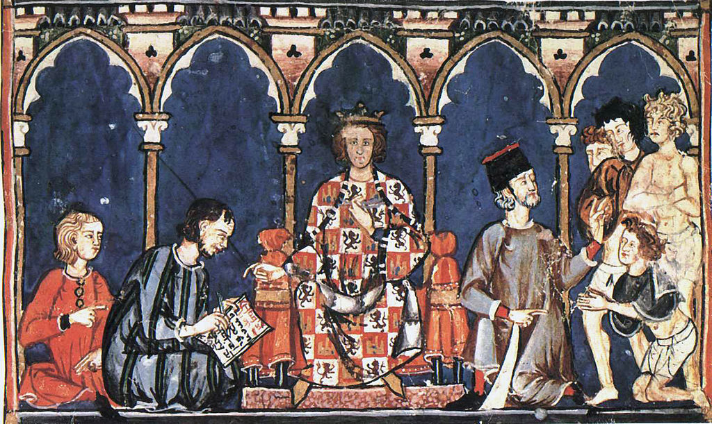

Alfonso X of León and Castille with his court. Alfonso X, commissioner, Libro de los juegos (Toledo: Toledo Scriptorium, 1283).

The historian’s enigma is to extract a logical and reliable narrative from material that is generally neither of those things. This statement is especially true for medieval primary sources which are rightfully considered articles whose information must be assessed with particular scrutiny. The often-sparse number of medieval sources available related to any singular topic compounds this problem and severely limits the historian’s capacity to gleam information via comparison. In this article for example, when researching the Asturian Kingdom, there are only three substantial sources to draw upon to assess its 192 year period: The Chronice of Albelda, The Chronicle of Alfonso III, and The Chronicle of Sampiro, and all three have been proved to be incorrect on several accounts. This article must therefore admit that medieval primary sources are limited in the extent to which they can tell us about relations within medieval hierarchies; we cannot claim that they reveal all facets of these relationships to us.
However just as these sources are not perfect, they are also not altogether flawed. There are certain types and areas of hierarchical relationships within Christian Iberia that our primary source material can be said to specialise in; this specialisation is primarily upon commercial transactions. Medieval records concerning what people are willing to pay for or receive in a transaction are appreciably more substantial than in other categories and financial information is unlikely to be falsified when multiple parties are involved who hold each-other accountable. Constructing a reliable economic history of power dynamics can therefore be achieved, with some influence from political history. Contrarily, producing a social, cultural, or intellectual history would be extremely challenging in this context. Economic sources like the Liber Feudorum Maier inform us about land allocation within a noble’s territory, the Chronica Adefonsi Imperatoris elucidates the practice of profiliatio whereby peasants enter into dependence of a lord, and the Historia Roderici refers to the cash payments given to vassals as reward for good service. The first thing these economic sources tell us is that the relationship between rulers and ruled in Christian Iberia was not one based upon intrinsic faith, authority, or right; from peasant to lord to monarch there was always an economic incentive provided to maintain the existing structures of power. The reason behind why unpaid slaves are scarcely mentioned in the primary sources for this period is because they were not involved in such commercial transactions. The extremely high value of slaves during this period also meant that they were infrequently traded, meaning they are rarely mentioned even as commodities.
The fact that our best historical sources concern economics and politics means that the aristocracy de facto becomes a further specialisation of our material. We can better assess the relationships within the aristocracy, wherein significant proportions of wealth are often traded, than between itself and the peasantry, even though the difference in relationship would evidently be far greater in the latter case. There are several categories of document that pertain almost exclusively to the aristocracy: fueros set out legal conditions for prestimonio, the process by which land could be taken away from the peasantry, property conveyances denote land acquired by nobles such as those of Count Suero and Countess Enderquina, often in relation to inheritance, and charters such as The Charter of 1152 show the priming of new land for exploitation. The fact that all these economic documents relate to land is also telling and shows the particular form of economic relationship that existed between rulers and ruled in this period, one that existed under what has been called a ‘quasi-feudal’ model.
What is the difference between a ‘quasi-feudal’ society and a simply “feudal” one, and what does that mean for relationships within the model? Firstly, our primary sources show us that the relationships between rulers and ruled in medieval Christian Iberia were to a certain extent symbiotic; each level of the hierarchy relied upon the others to either generate or protect income for them. Additionally, the nobility and monarchy were involved an exchange process of prestige; kings and queens would look to the endorsement of nobles as vindications of their legitimacy whilst nobles placed much importance on receiving titles, particularly comites. However, it would be incorrect to frame this power structure as a pyramid, with the monarch in absolute control, as a feudal model is traditionally constructed. Indeed, the influence of noble families could often rival or exceed that of the monarch, as seen in the war between Alfonso VII and Gonzalo Peláez in which the king was forced to make significant concessions to the rebel as documented in the Chronica Adefonsi Imperatoris. Medieval Iberia was quasi-feudal because its royals had high status but their power rested on their ability to control their ‘regional potentates’.
These relationships were as volatile as they were co-dependent. If economic incentives were insufficient for one level of social strata, they could turn on another; as the veneer of a united Christian front against Islamic oppressors fell rapidly away. In the records of the Cortes we can see how co-operation was only managed between monarchy and nobility when tax concessions were made. The Usages of Barcelona carefully draws a separation between independent levels of aristocratic power in terms of who has which right to extract wealth from the land. Indeed, conflict existed not just between levels of hierarchy, but also within them; Alfonso VI was required to act as a ‘chief justiciar’ to mediate between the various nobles and factions within his court.
Despite our sources primarily pertaining to aristocratic power dynamics, we can draw some conclusions which apply to the proletariat by asking the right questions of our material. Why were rebellious local lords not turned upon by their own vassals in favour of the monarch who was, after all, their ultimate leader? The answer must be that the people did not hold unswerving allegiance to the royalty. Indeed, the medieval Christian Iberian peasant held a distinctly ‘de-centred’ world view, within which they held loyalty to people, not positions. A new ruler would have to act quickly to establish themselves as worthy of their own rank, they could not simply rely on being unquestioningly accepted into the role, as shown with Queen Urraca in the Historia Compostelana. Monarchs such as Alfonso II and Alfonso III likened themselves to old Visigoth rulers in their self-propaganda in order to make themselves palatable to their subjects. This devolutionary perspective was a symptom of medieval Christianity, which envisaged a universal “kingdom of Christ” that all rulers were ultimately subservient to. Conceptually this world-wide dominion could not be escaped no matter your ruler, as is evident from descriptions within the Consilia of Oldradus da Ponte. This relative ambivalence to leadership was expedited by the significant periods of unrest that the people of medieval Iberia experienced, most infamously during the time of the “party kings”. Cities and peoples found it difficult to foster an attachment to their ruler when they expected they may be replaced in the not-too-distant future. Even outside of these times the upper classes were not a fixed establishment and powerful families could rise as well as fall from grace relatively often.
Religion institutionally played a far divergent role from that which it played conceptually. Our economic primary sources reveal a relationship dynamic between the papacy and the aristocracy in which who could be called ruler and who could be called ruled is difficult to assess. Ultimately, I would deem the aristocracy to hold more power than the church but not to such a significant level that it could be said to rule over it. This conclusion is reached because in several other contemporaneous European countries, most notably in the regions of what we today call France and Germany, peoples lived more by canon law than civil, but this was not the case in Iberia. Primary accounts like that of the Bayan or the Cronica Albeldero reveal to us the image of a monarchy of distinctly secular character that saw little need to go through the church to claim connection to god. However other sources such as monastic cartularies show us the economic power of the church; the land and wealth accrued by monasteries and cathedral churches meant that rulers still had to be careful to heed the word of bishops for fear of losing the income they could provide.
Primary records that relate directly to the power dynamics of common people are rare. Generally we find that sources only exist where disputes have turned into more active forms of resistance such as the rebellion on the estate of the House of Lara in the early 14th century, which appears part of a wider trend of resistance beginning in the 1300s. However it must be noted that the remains of archives of noble families are effectively non-existent pre-14th century and so there was likely more popular resistance to seigneurial power in the preceding centuries for which we have little documentary evidence. This highlights a weakness of primary material, the sources we don’t have can be just as influential on our assessments of the past as those that we do.
Ultimately, with consideration of their flaws, medieval primary sources in an economic context are able to reveal certain facets of the relationships between rulers and ruled in Christian Iberia. They tell us that within a de-centred quasi-feudal world the peasants, aristocrats, monarchs, and bishops were often reliant on one another to exist symbiotically. However, they also tell us that these were relationships fraught with conflict and complex power dynamics that did not always fall into a neat pyramidical structure. For each-other they were their greatest allies whilst simultaneously being potentially potent enemies.
Author Publisher: Louis Lorenzo
Date of Publication: 8th of December 2018

Bibliography
Albert, Pere. The Customs of Catalonia between Lords and Vassals. Translated by Donald J. Kagay. Tempe: Arizona Center for Medieval and Renaissance Studies, 2002.
Barton, Simon., and American Council of Learned Societies. The Aristocracy in Twelfth-century León and Castile. Cambridge; New York: Cambridge University Press, 1997.
Collins, Roger. Caliphs and Kings: Spain, 796-1031. Chichester; Malden: Wiley-Blackwell, 2012.
Cook, William R., and Ronald B. Herzman. The Medieval World View: An Introduction. 2nd ed. Oxford: Oxford University Press, 2004.
Doubleday, Simon R. The Lara Family: Crown and Nobility in Medieval Spain. Cambridge; London: Harvard University Press, 2001.
Noble, T.F.X., J.M.H. Smith., and R.A. Baranowski., editors. Early Medieval Christianities, c.600-c.1000. Cambridge: Cambridge University Press, 2010.
O’Callaghan, J.F. “The Cantigas de Santa Maria as an historical source: two examples.” In Alfonso X, the cortes, and Government in Medieval Spain, edited by J.F. O’Callaghan. Farnham: Ashgate, 1998. 387-402.
Powell, James M. Muslims Under Latin Rule, 1100-1300. Princeton: Princeton University Press, 1990.
Reilly, Bernard F., and American Council of Learned Societies. The Kingdom of Leon-Castilla under King Alfonso VI, 1065-1109. Princeton: Princeton University Press, 1988. ACLS Humanities E-Book. Accessed November 4, 2018. https://libro.uca.edu/alfonso6/alfonso.htm.
Reilly, Bernard F., and American Council of Learned Societies. The Kingdom of Leon-Castilla under Queen Urraca, 1109-1126. Princeton: Princeton University Press, 1988. ACLS Humanities E-Book. Accessed November 4, 2018. https://libro.uca.edu/urraca/urraca.htm.
Reilly, Bernard F., and American Council of Learned Societies. The Kingdom of León-Castilla Under King Alfonso VII, 1126-1157. Princeton: Princeton University Press, 1988. Accessed November 3 2018. https://www-degruyter-com.libproxy.ncl.ac.uk/viewbooktoc/product/483400.
Wasserstein, David. The Rise and Fall of the Party-kings: Politics and Society in Islamic Spain 1002-1086. Princeton: Princeton University Press, 1985.

Roger Collins, Caliphs and Kings: Spain, 796-1031 (Chichester; Malden: Wiley-Blackwell, 2012), 51.
Found in: Pere Albert, The Customs of Catalonia between Lords and Vassals, trans. Donald J. Kagay (Tempe: Arizona Center for Medieval and Renaissance Studies, 2002), 37.
Found in: Simon Barton and American Council of Learned Societies, The Aristocracy in Twelfth-century León and Castile (Cambridge; New York: Cambridge University Press, 1997), 90.
Ibid, 91.
Ibid, 82.
Ibid, 82.
Albert, The Customs of Catalonia between Lords and Vassals, 11.
Barton, The Aristocracy in Twelfth-century León and Castile, 69.
Ibid, 100.
Albert, The Customs of Catalonia between Lords and Vassals, 9.
Barton, The Aristocracy in Twelfth-century León and Castile, 110.
Bernard F. Reilly and American Council of Learned Societies, The Kingdom of León-Castilla Under King Alfonso VII, 1126-1157 (Princeton: Princeton University Press, 1988), accessed November 3, 2018, https://www-degruyter-com.libproxy.ncl.ac.uk/viewbooktoc/product/483400.
Collins, Caliphs and Kings: Spain, 796-1031, 149.
David Wasserstein, The Rise and Fall of the Party-kings: Politics and Society in Islamic Spain 1002-1086 (Princeton: Princeton University Press, 1985), 251.
J.F. O’Callaghan, “The Cantigas de Santa Maria as an historical source: two examples,” in Alfonso X, the cortes, and Government in Medieval Spain, ed. J.F. O’Callaghan (Farnham: Ashgate, 1998), 396.
Albert, The Customs of Catalonia between Lords and Vassals, 36.
Bernard F. Reilly and American Council of Learned Societies, The Kingdom of Leon-Castilla under King Alfonso VI, 1065-1109 (Princeton: Princeton University Press, 1988), accessed November 4, 2018, https://libro.uca.edu/alfonso6/alfonso.htm, chap.18, 4.
T.F.X. Noble, J.M.H. Smith, and R.A. Baranowski, eds. Early Medieval Christianities, c.600-c.1000 (Cambridge: Cambridge University Press, 2010) 4.
Bernard F. Reilly and American Council of Learned Societies, The Kingdom of Leon-Castilla under Queen Urraca, 1109-1126 (Princeton: Princeton University Press, 1988), accessed November 4, 2018, https://libro.uca.edu/urraca/urraca.htm, chapter 12, 4. Also: Barton, The Aristocracy in Twelfth-century León and Castile, 111.
Wasserstein, The Rise and Fall of the Party-kings: Politics and Society in Islamic Spain 1002-1086, 259.
Noble, Early Medieval Christianities, c.600-c.1000, 2.
James M. Powell, Muslims Under Latin Rule, 1100-1300 (Princeton: Princeton University Press, 1990) 207.
Wasserstein, The Rise and Fall of the Party-kings: Politics and Society in Islamic Spain 1002-1086, 292.
Barton, The Aristocracy in Twelfth-century León and Castile, 86.
William R. Cook and Ronald B. Herzman, The Medieval World View: An Introduction, 2nd ed (Oxford: Oxford University Press, 2004), 201.
Wasserstein, The Rise and Fall of the Party-kings: Politics and Society in Islamic Spain 1002-1086, 250.
Collins, Caliphs and Kings: Spain, 796-1031, 150.
Doubleday, The Lara Family: Crown and Nobility in Medieval Spain, 127.
Barton, The Aristocracy in Twelfth-century León and Castile, 71 and 99.

