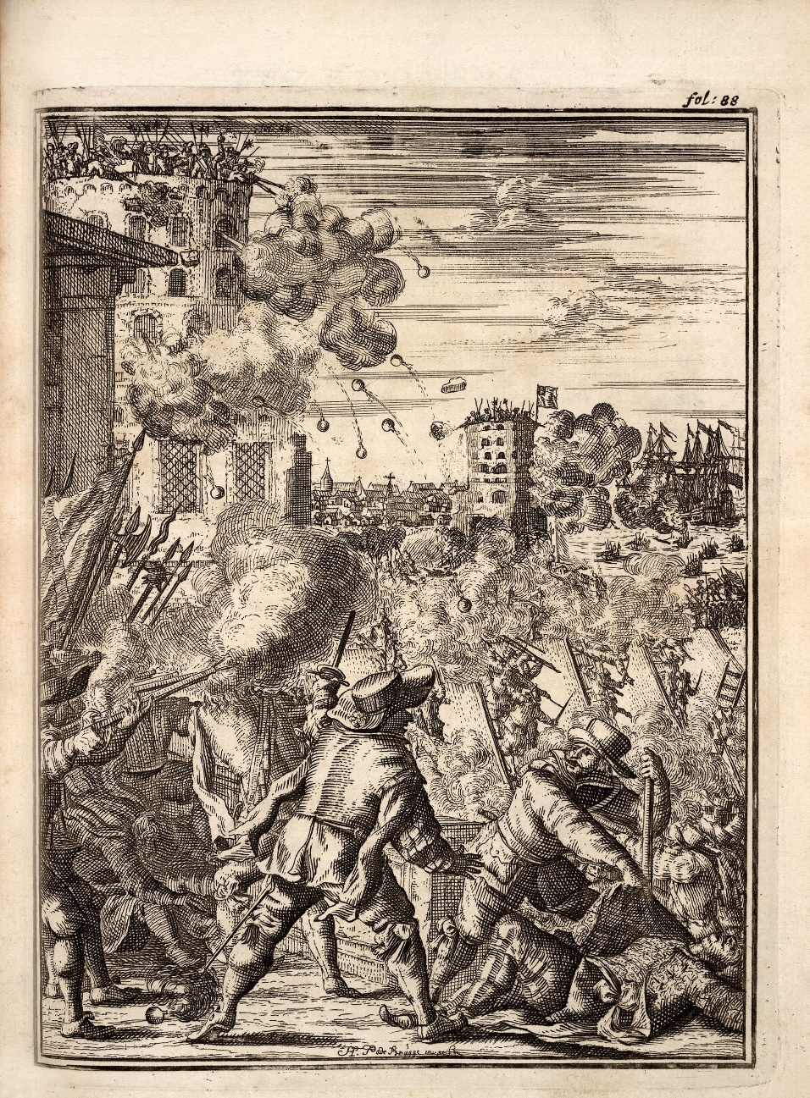

Illustration from: Alexander O. Esquemeling, The Buccaneers of America (Amsterdam: 1678).

Author/Publisher: Louis Lorenzo

For as long as there has been sea-faring trade, there have been people who seek to exploit its riches; pirates, the ‘enemies of all mankind’. To describe pirates, a group traditionally known as quintessentially villainous, as “social bandits” seems initially preposterous but the more we learn about their egalitarian societies the more plausible this description becomes. For this article I am using Eric Hobsbawm’s definition of social banditry, namely:
‘peasant outlaws whom the lord and state regard as criminals, but who remain within peasant society, and are considered by their people as heroes’
In this article I will be considering various aspects of piratical society and whether these aspects allow the pirate to fall into the category of “social bandit” described above or otherwise. Assessing whether pirates match the four main requirements stipulated above of being ‘peasant’, ‘criminals’, ‘within peasant society’, and ‘considered by their people as heroes’.
Firstly, can pirates be described as ‘peasant’? The answer to this is comprehensively that they can. Although there were some notable exceptions, such as with the case of Major Bonnet, the average pirate was both poor and of low social status, the very quintessence of peasant-hood. Marcus Rediker describes pirates as ‘dispossessed proletarians’, people who saw piracy as a chance to increase both their social and monetary wealth. As well as this piracy also represented a form of counterculture, a certain freedom and liberty outside of the existing social order. In this ideological sense, many similarities can be drawn between pirates and colonists; Paul Gilje explains that in both cases individuals were given great independence from existing society and ‘the chance to make many decisions of their own accord’. This ideal of rebellion against society is one central to the notion of the social bandit because it insights antagonism against the ruling elite, who represent the society you have divorced from, whilst simultaneously creating an association with the “common people”. Pirates would generally have already held a maritime occupation of low social standing before their stint as outlaws; they may well have been fishermen, crews on merchant vessels, or privateers. As such, the difference in lifestyle between the two roles was often not very different and made it easy for those of pre-existing peasant status to convert to piracy. For those of high social status it would constitute a particularly exhaustive change in lifestyle to become a pirate and this is one prominent factor in deterring such classes.
Secondly, were they regarded as ‘criminals’ by officials and the state? This is also a definite positive. Pirates were agreed to be criminals not only domestically, but also on the international stage as they attacked all factions active in the Atlantic including the British, French, Dutch, and Spanish. This is because, as Kris Lane identifies, pirates did not pose against any individual nation, but against the very ideal of nationhood itself through an ‘almost universal rejection of national and religious authorities’. As Amedeo Policante states, piracy created the need for an international legal response, the Ius Publicum Europaeum (“European Public Law”). This meant the removal of amity lines between European states and the ‘collective appropriation of the oceans’. Phil Steinberg argues that with this framework in place any ship not attached to a nationality could thence be apprehended as an agent of the ‘anti-civilisation of the sea’. A 1696 case against Captain Avery’s crew led an English judge to rule that he had ‘jurisdiction over all people – anywhere on earth – who interfered with English commerce’, this was a direct criminalisation of piracy. Charles Johnson’s 1724 text on piracy shows us that pirates were actively punished and that the laws set against them were used in practice, not only in theory. He vividly describes the numerous public executions of the pirates he documents within his text and how their deaths were to be "without Benefit of Clergy, and forfeit Land and Goods." This form of dishonourable execution is evidence of the authorities’ specific disdain for criminal piracy.
Thirdly, did pirates ‘remain within peasant society’? In other words, did piracy remove people from their “roots” or did pirates continue to care about the welfare of those still within the peasant society they left behind? This question is less clear-cut to answer as the previous two but on balance I do believe that this is also the case. Certainly, there was a universal community between pirates themselves, who were willing to cooperate with each other ‘even when the various crews were strangers to each other’. Indeed, in many ways pirates led more inclusive societies than their landlubbing adversaries; according to Richard Burg they promoted a ‘multicultural, multiracial, and multinational social order’. This meant pirates were able to not only remain within peasant society, but expand it to include people of varying backgrounds. Also, since it was highly unlikely any individual pirate would survive more than three years a-sea there was a constant influx of new peasants joining pirate crews and these kept pirates close to the peasant societies from which they came. However, this does not detract from the fact that pirates, in the end, held allegiance only to themselves and would not shy away from putting any peasant to the cutlass should they refuse to join their crew. This is likely why so many captured seamen “volunteered” to join pirate crews, which was favoured because it was thought this would create a better social cohesion between the sailors. Female pirates were also expressly banned on pirate vessels by the pirate code. This does not show express antagonism towards peasants however, because pirates were indiscriminatory in this sense, and would give the same treatment to any person who would defy them. Pirates were also far more inclusionary toward people with disabilities, which would be disproportionately those of the peasant classes; it is not coincidence the peg-leg and the eye-patch are engrained onto the modern perception of the pirate. Indeed, pirates were the authors of the first ever workers compensation scheme whereby sailors could be paid for their injuries sustained. They also supported democracy aboard ship, a practice which clearly supports the majority over a ruling elite. The last words of William Fry during his extraordinary execution were ones of solidarity with peasant society; informing the crowd that ship captains could avoid their crews turning to piracy if they would only “treat them humanly”. Pirates also contributed to local economies in ways which the European states didn’t, Jason Acosta explains how pirates ‘didn’t bury their treasure, they spent it, helping colonies survive that couldn’t get the money and supplies they needed from Europe’. This is an exact definition of social banditry, robbing from the rich and giving to the poor.
Fourthly, were pirates ‘considered by their people as heroes’? This somewhat depends on how you may define ‘their people’ but it is logical that Hobsbawm is referring to the “peasant society” that he previously mentioned herein. Were pirates generally supported amongst the common folk? Alas, it is here that the pirate falls at this final hurdle, as although many pirates perhaps saw themselves as activists for the people, and were admired by some, they were generally not well regarded by the public. Initially perhaps there was a moment in the late 17th century where pirates lay favourable in the public eye when states were hiring their own privateers to combat enemy states. In this context, Claire Jowitt argues that pirates could be portrayed as the ‘shrewd mercantile venturer’ or perhaps even the ‘heroic gentleman adventurer’, despite their violent occupation. For example, in 1694 a ballad titled “A Copy of Verses, Composed by Captain Henry Every [Avery]” argued strongly in favour of the pirate captain and for some period solidified him as a folk hero, making his trial a great difficulty. However, as Sarah Barringer points out, as the admiralty began to withdraw its support for privateers at the turn of the 18th century the public mood quickly began to change with it. She shows how this turn in official position coincided with the rise of the coffee house and a newly created ‘public sphere’ and how the state line ‘influenced the public sphere’. Before, the public had seen it a great hypocrisy to convict a pirate whilst supporting privateers but now this hypocrisy no longer existed, and the officials were efficient in defaming the pirate image from thence onward. The difference between Captain Avery’s trial of 1696 and Captain Kidd’s of 1701 is marked. During Kidd’s trial the prosecutor shifted the narrative away from that which had accused Captain Avery (which focussed on violence), and toward the economic detriment of piracy. Although the now infamous phrase “enemies of all mankind” was not used, the prosecutor did describe Kidd as ‘the common enemy of mankind’. The image of piracy was further weakened in 1714 with the end of the War of the Spanish Succession which allowed pirates to attack English ships more freely. Pirates progressed in the public consciousness from heroes to villains.
Pirates very almost fit the definition of the social bandit forwarded by Eric Hobsbawm, and for a brief moment in history, I argue, they did indeed hold that title. They were from ‘peasant’ society, were considered ‘criminals’ by authorities and states, and they remained ‘within peasant society’. However, despite their displaying many characteristics of “social bandits” from elsewhere, a real social bandit requires the support of the general populous to be legitimate, and pirates simply did not have that support. In many ways this was a support that was taken from them, a direct result of a concerted effort by the state to deface the pirate image, and in some ways, this seems an injustice. However, due to the bloody nature of their profession, I do not consider it a great wrong done to them.

Bibliography
Acosta, Jason. “Pirates pursued democracy, helped American colonies survive.” Accessed 04th December 2017. http://news.ufl.edu/archive/2006/06/study-pirates-pursued-democracy-helped-american-colonies-survive.html.
Barringer, Sarah. “Enemies of Mankind: The Image of Pirates in 18th-Century England.” Primary Source 5 (2014): 1-11.
Burg, Richard. Sodomy and the pirate tradition: English sea rovers in the seventeenth century Caribbean. New York: New York University Press, 1995.
Gilje, Paul A., Liberty on the Waterfront. Philadelphia: University of Pennsylvania Press, 2004.
Heller-Roazen, Daniel. The Enemy of All: Piracy and the Law of Nations. New York: Zone Books, 2009.
Hobsbawm, E. J. Bandits. New ed. London: Abacus, 2001.
Jarus, Owen. "Blackbeard's Booty: Pirate Ship Yields Medical Supplies." Accessed 06 December 2017. https://www.livescience.com/49563-blackbeard-pirate-ship-yields-medical-supplies.html.
Johnson, Charles. Pirates: A General History of the Robberies and Murders of the Most Notorious Pirates. London: Conway Maritime, 2002.
Jowitt, Claire. The Culture of Piracy, 1580-1630: English Literature and Seaborne Crime. Surrey: Ashgate Publishing Limited, 2010. 137.
Lane, Kris. Pillaging the Empire: Piracy in the Americas, 1500–1750. Armonk: M. E. Sharpe, Inc., 1998.
Policante, Amedeo. The Pirate Myth: Genealogies of an Imperial Concept. Oxford: Routledge, 2015.
Rediker, Marcus. Villains of All Nations: Atlantic Pirates in the Golden Age. London: Verso, 2004.
Steinberg, Phil. The Social Construction of the Ocean. Cambridge; New York: Cambridge University Press, 2001.
The Arraignment, Tryal, and Condemnation of Captain William Kidd, for the Murther and Pyracy. London: J. Nutt. 1701. 14.

Daniel Heller-Roazen, The Enemy of All: Piracy and the Law of Nations (New York: Zone Books, 2009).
Marcus Rediker, Villains of All Nations: Atlantic Pirates in the Golden Age (London: Verso, 2004).
E. J. Hobsbawm, Bandits. New ed (London: Abacus, 2001). I am using Hobsbawm’s definition because it is both the original and has gone relatively unchallenged since 1959.
Who was ‘a gentleman of good reputation’ according to Captain Charles Johnson in: Charles Johnson, Pirates: A General History of the Robberies and Murders of the Most Notorious Pirates (London: 1724).
Rediker, Villains of All Nations: Atlantic Pirates in the Golden Age.
As described in: Paul A. Gilje, Liberty on the Waterfront, (Philadelphia: University of Pennsylvania Press, 2004).
Ibid.
Kris Lane, Pillaging the Empire: Piracy in the Americas, 1500–1750 (Armonk: M. E. Sharpe, Inc., 1998).
Amedeo Policante, The Pirate Myth: Genealogies of an Imperial Concept (Oxford: Routledge, 2015).
Ibid.
Phil Steinberg, The Social Construction of the Ocean (Cambridge; New York: Cambridge University Press, 2001).
Rediker, Villains of All Nations: Atlantic Pirates in the Golden Age.
Johnson, Pirates: A General History of the Robberies and Murders of the Most Notorious Pirates, 337-339.
Rediker, Villains of All Nations: Atlantic Pirates in the Golden Age.
Richard Burg, Sodomy and the pirate tradition: English sea rovers in the seventeenth century Caribbean (New York: New York University Press, 1995).
Refusal to join would mean death unless you possessed any particularly needed skill, such as being a surgeon: "Blackbeard's Booty: Pirate Ship Yields Medical Supplies," Owen Jarus, accessed 06 December 2017, https://www.livescience.com/49563-blackbeard-pirate-ship-yields-medical-supplies.html.
Rediker, Villains of All Nations: Atlantic Pirates in the Golden Age.
Rediker, Villains of All Nations: Atlantic Pirates in the Golden Age. Rediker describes this as a ‘common wealth’ plan.
Rediker, Villains of All Nations: Atlantic Pirates in the Golden Age.
“Pirates pursued democracy, helped American colonies survive,” Jason Acosta, accessed 04th December 2017, http://news.ufl.edu/archive/2006/06/study-pirates-pursued-democracy-helped-american-colonies-survive.html.
Claire Jowitt, The Culture of Piracy, 1580-1630: English Literature and Seaborne Crime (Surrey: Ashgate Publishing Limited, 2010), 137.
Douglas R. Burgess, “Piracy in the Public Sphere: The Henry Every Trials and the Battle for Meaning in the Seventeenth-Century Print Culture,” The Journal of British Studies 48, no. 4 (2009): 894-5.
Sarah Barringer, “Enemies of Mankind: The Image of Pirates in 18th-Century England,” Primary Source 5 (2014): 1-11.
The Arraignment, Tryal, and Condemnation of Captain William Kidd, for the Murther and Pyracy (London: J. Nutt. 1701), 14.

