Devoted Admirers and Bitter Enemies
Assessing our current understanding of T. Dan Smith

Part 3: Sources
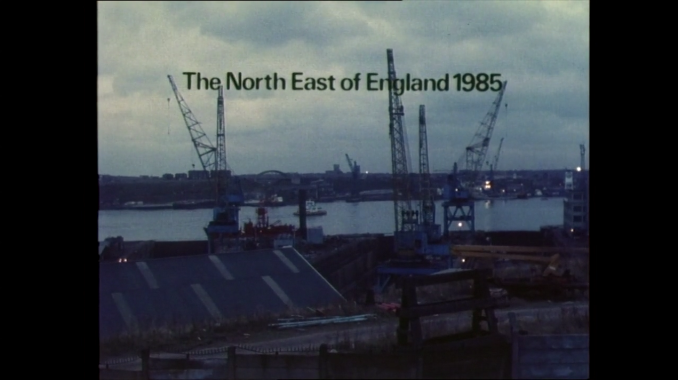

Opening Scene from ‘A Funny Thing Happened on the Way to Utopia’ (Amber Collective, 1987).

Written and Published by Louis Lorenzo

Thomas Daniel Smith will always exist as a controversial figure, a polariser of public opinion. For the people of Newcastle-upon-Tyne his legacy is unavoidable, it is spread all over the city in the form of vast swathes of concrete, often ill-repaired and forgotten, which speak of a separate world from that of the Victorian terraces and Georgian streets. For some, his imprisonment on charges of corruption in 1974 was a justice well served to a politician who had taken advantage of the city to better himself and those close to him. For others, and for Smith himself, he had been pilloried by a political establishment who saw him as a threat to their own authority and made the scapegoat for higher ranking officials who were the truly corrupt forces at play. As he put it, he had to be disposed of because he ‘wasn’t one of them’. The three sources I investigate herein have been chosen to help me examine the character of T. Dan Smith in public life and understand how the public perception of him has been informed by the media that portrayed him. Primarily however I examine the man’s vision and assess whether his passionate talk of creating a ‘new Brasilia’ was merely a show to cover his untoward deeds or whether it did truly represent a devotion to positive change. Ultimately, I will conclude that these sources indicate that he did.
The earliest of my three sources dates from 1969, before allegations of Smith’s involvement in corruption came to the fore. It is a booklet distributed by the Northern Economic Planning Council (NEPC) which sets out its vision for north-east development over the next 12 years up toward 1981. Smith was the chairman and head of the NEPC at this time and he wrote in the foreword to the document that it should be ‘given the widest possible circulation within the region’. It is a statement of desire for the future and I will be assessing it to determine exactly what Smith envisioned he could achieve in the region if his tenure had not been cut short by a jail sentence 6 years later. It also shows us what Smith though most important to communicate to the people of the region.
The second of my three sources dates from 1971, three years before Smith would be convicted on charges of corruption, however it does still originate from a time when Smith was embroiled in allegations of corruption brought against him. The source itself is a correspondence between Smith and Henry Parris (Smith’s friend and a lecturer in politics at Durham university) and it follows straight after a 1971 corruption trial for which Smith was found not guilty. Parris’ letter to Smith also includes an attached newspaper article from the guardian which he explains is from where he learned about Smith’s trial. I will be using this source to assess public attitudes towards Smith before he pleaded guilty to corruption and to examine how he was depicted in the media during this tumultuous time.
My final source dates from 1987, after Smith had been released from jail and somewhat receded from the public eye. It is a documentary film produced by Newcastle-based studio “Amber Films” which includes interviews with Smith and with several other persons from his history. From this source we get to assess Smith’s responses to the allegations made against him and how his legacy was remembered publicly after his spotlight had since faded.
The NEPC booklet does not provide an optimistic view of the future for the north-east, indeed, it is resolved to a process of damage mitigation; using phrases such as ‘the region cannot hope to halt net outward migration’ and ‘heavy job loss… will almost certainly continue into the mid-1970s’. At initial observation this does not align well with T. Dan Smith’s notion that he could turn Newcastle into the ‘Venice of the north’, as he would sometimes claim. However, reading further into the NEPC’s policy proposals reveals that this is not the case. This is because the document outlines a strategy of concentrating all resources towards certain key areas of economic activity within the region at the expense of others; Newcastle being the foremost of these chosen areas. In astonishing brusqueness, as this document was made widely available to the general public, it pronounces that ‘There is no point in pretending that all the communities which now exist in the region will be capable of surviving’ and states that ‘this policy would accept… a gradual rundown of some of the less favourably placed communities’. The spines around which these ‘growth areas’ will be built were the proposed ‘growth corridors’; an idea based on the conclusion that roads are critical to the economy and that investing in road infrastructure will bring wealth to the area that surrounds them. This came to Smith through his city planner Wilfred Burns who took much inspiration from modern American cities. This is why most of the “new towns” built during this period, such as Washington and Meadowfield, were deliberately based around ‘motorway interchange points’. Comparing the map showing proposed ‘growth corridors’ against a concurrent plan for road extensions reveals how exactly these two plans align. Indeed, the ‘main growth corridor’ aligns exactly with the line of the A1 motorway.
This document reveals the harsher side of Smith’s visionary rhetoric. Within this document genuine and practical belief is shown in the ability of Newcastle to foster ‘seeds of future growth and prosperity’ but this is acknowledged only at the expense of other areas in the region. What this does help us acknowledge however, is the practicality at the heart of Smith’s vision; he does not outline a perfect scenario and nor does he claim to hold all the answers, but he does want to attempt an ambitious strategy for turning the fortunes of the region around. This is not a document produced by a man who does not understand the realities of his situation and is a demonstration of Smith’s unreservedness in communicating to the people of the area what he intends to realistically achieve.
It is interesting therefore to see in the newspaper article attached to the letter sent from Henry Parris to Smith how the media of the time portrayed this unreserved vision. What is immediately communicated through this source is the real respect and influence he had garnered for himself despite the allegations brought against him. He is described as the man who ‘virtually invented regionalism’ and the article plays up his “rags to riches” tale, a man ‘unfettered by formal education’. The context of this article within this correspondence via letter also enforces the conclusion that Smith was well thought after, a foreword stating that he had received ‘hundreds of messages’ of support. Smith’s determination to carry on with his work is also evident here, which he states very plainly in both his newspaper interview and his personal reply to Parris: ‘I am planning my diary again with confidence’. It is interesting and slightly sad to note this optimism in the knowledge of his imprisonment that would follow this correspondence only 3 years later.
However, there is a clear subtext to pick up when assessing this source which does imply that Smith had his detractors at this time, which he certainly did. A fault of this source is that it does not fully represent the other side of the argument as it only includes comment from those predisposed towards Smith: his friend and a newspaper which broadly aligns with himself politically. Nonetheless when Parris writes that ‘I felt I could not remain silent’ or when the paper writes that Smith commanded over a ‘reluctant Newcastle-upon-Tyne’ it is made clear that Smith was not universally admired. Indeed, overall across all of the three primary sources I examine the picture developed of T. Dan Smith is a mixed one, a man who attracted ‘devoted admirers and bitter enemies’.
Certainly the 1987 Amber documentary brings the conflicting elements of Smith’s career to the fore, using its two narrators as points from which to argue the two sides of the story; one a detractor and the other a supporter. The film shows a society which finds it difficult to come to grips with Smith’s character, a man who cannot be simply labelled into the category of hero or villain. In particular its interviews with members of the general public of Newcastle prove enlightening; an ambivalent atmosphere flows through all of these conversations which seem to both condemn and praise at the same time. One man states: ‘He did a wonderful job for the town, but unfortunately he was found out’ and another: ‘to me he’s a criminal… but now he’s more or less hailed as a hero’. The interviews with Smith himself show a very different character to that seen in the newspaper and the NEPC document. These detail him as a bold and harsh character, not afraid to offend in order to get things done. Now, after his time in jail, the man set before us is defensive and calculating, carefully choosing his words to justify and explain his former selves. In regard to the public opinion of himself, he says that people seem to ‘reflect the society that was able to convince them of what ever they want to be convinced of’, in other words, he feels the public have been misled as to his role in the wider corruption scandal involving the architect John Poulson and the conservative home secretary Reginald Maudling. His view is now that he was made a scapegoat for ‘bigger fish’, and although he did plead guilty to charges of corruption he now claims to be innocent.
Certainly, his decision to appear on such a program does lend a legitimacy to his assertions. We see him now, still living in Newcastle, in one of the very concrete towers he laid the foundations for. He lives no ‘life of luxury’, as one of the citizens claims, he appears as he proclaims himself, cast out. Overall the feature does portray Smith in a sympathetic light and does not take such a balanced view as it wishes you to believe it is taking. It is another example, as with the newspaper, the letter, and the NEPC booklet, of people being swept along in the wake of T. Dan Smith. Through all of the sources his personal drive and commitment appears infectious on those around him, a naturally likeable character.
What these sources all indicate is that T. Dan Smith did have a genuine vision and love for his home city. As to the extent of his involvement in the corruption scandal I do not believe these sources provide enough information to make an informed assessment of that. What they do show is that across time, from his heyday to his downfall to the present, he remains a man who can inspire passion in those around him.

Author/Publisher: Louis Lorenzo
Date of Publication: 3rd of August 2018

Bibliography
Ardill, John. “The Mouth of the Tyne.” The Guardian, 9 July 1971.
Cotgrove, Steven. “Obituary: Henry Parris.” The Independent, 2 March 1996.
Nally, Mike. T. Dan Smith. Film. Directed by John Mapplebeck. London: BBC, 1986.
Pendlebury, John. "Alas Smith and Burns? Conservation in Newcastle upon Tyne city centre 1959–68." Planning Perspectives 16 (2001): 115–141.
Smith, T. Dan. A Funny Thing Happened on the Way to Utopia. Film. Directed by Elaine Drainville. Newcastle: Amber Films, 1987.
Unknown Author. "Powerbroker who fell from grace." The Financial Times, 28 July 1993.
Unknown Author. "The rise and fall of Mr Newcastle." The Journal, 10 March 2004.
Waterhouse, Robert. "T. Dan Smith (Obituary)." The Guardian, 28 July 1993.
Wood, Chris Foote. T Dan Smith:"voice of the north" - downfall of a visionary : life of the north-east's most charismatic champion. County Durham: Northern Writers, 2010.

Source A1
Location: Tyne and Wear Archives, Discovery Museum, Newcastle-upon-Tyne
Title: Letter, Henry Parris, Wokingham, to T Dan Smith, Newcastle
Reference Number: DX1278/1
Date: 27th of July 1971
Description: Letter sent from Henry Parris to T. Dan Smith expressing Parris’ sympathies for Smith after his trial for corruption and explaining how he read about the trial in the newspaper.
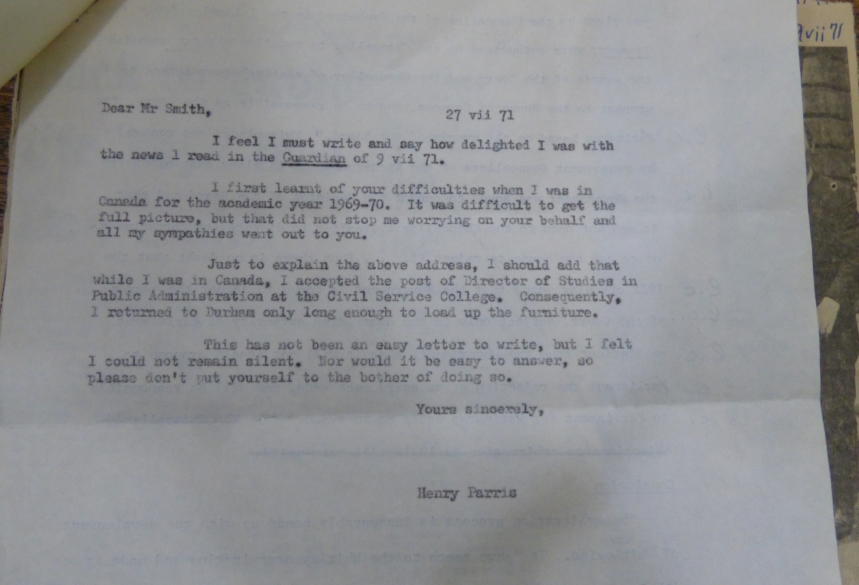

Source A2
Location: Tyne and Wear Archives, Discovery Museum, Newcastle-upon-Tyne
Title: Letter, Henry Parris, Wokingham, to T Dan Smith, Newcastle
Reference Number: DX1278/1
Date: 9th of July 1971
Description: Attached article from the guardian newspaper reporting on the T. Dan Smith trial.
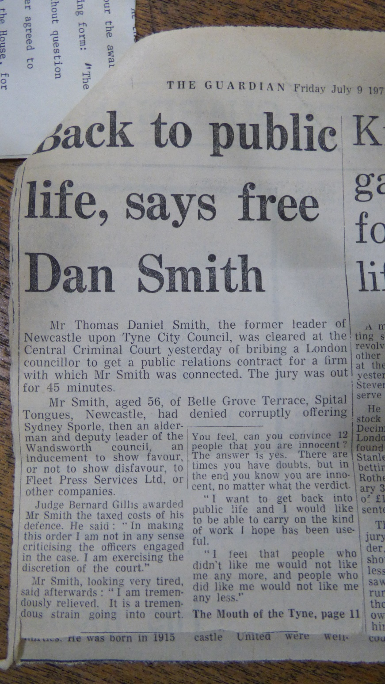

Source A3
Location: Tyne and Wear Archives, Discovery Museum, Newcastle-upon-Tyne
Title: Letter, Henry Parris, Wokingham, to T Dan Smith, Newcastle
Reference Number: DX1278/1
Date: 9th of July 1971
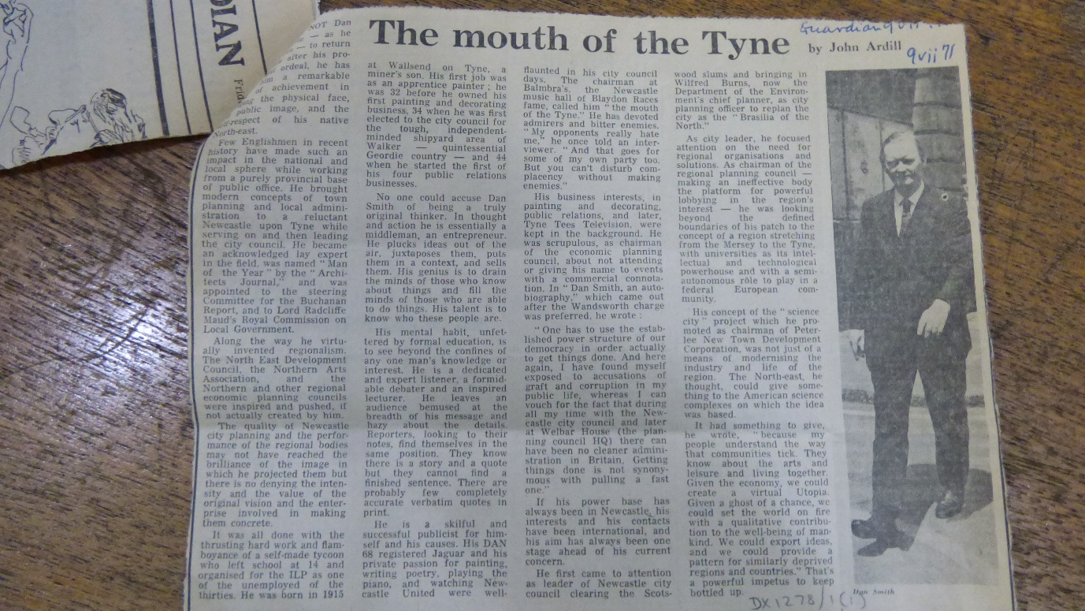
Description: Continued article reporting on T. Dan Smith’s trial and giving an overview of his character and accomplishments.

Source A4
Location: Tyne and Wear Archives, Discovery Museum, Newcastle-upon-Tyne
Title: Reply from T Dan Smith to Henry Parris
Reference Number: DX1278/2
Date: 28th of August 1971
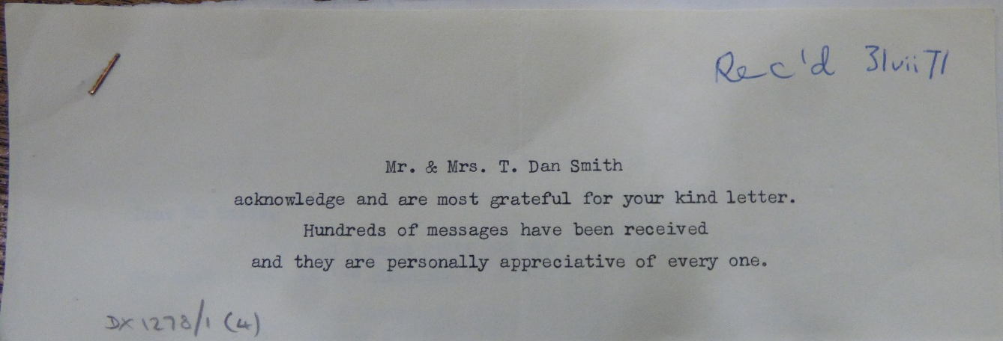
Description: Cover slip associated with T. Dan Smith’s reply to Henry Parris which gives a general message of gratitude.

Source A5
Location: Tyne and Wear Archives, Discovery Museum, Newcastle-upon-Tyne
Title: Reply from T Dan Smith to Henry Parris
Reference Number: DX1278/2
Date: 28th of August 1971
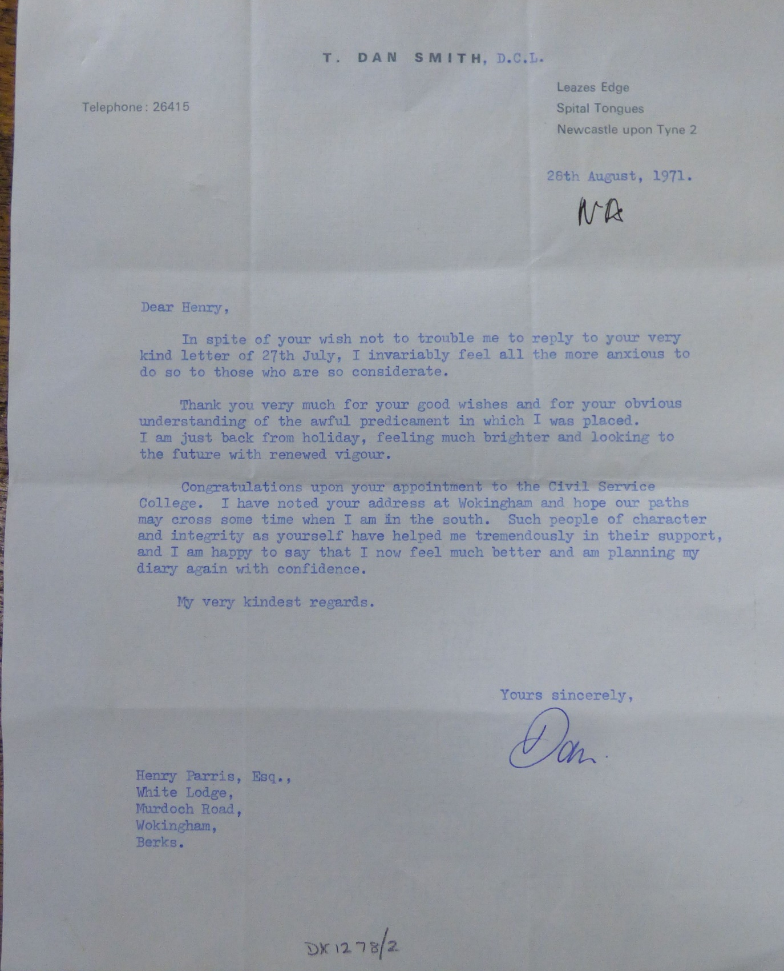
Description: Typed letter from T. Dan Smit in reply to Henry Parris discussing his gratitude for Parris’ good wishes towards him on his acquittal after his 1971 trial.

Source B1
Location: Tyne and Wear Archives, Discovery Museum, Newcastle-upon-Tyne
Title: Northern region: An Outline strategy of development to 1981
Reference Number: L/PA/1457
Date: 1969
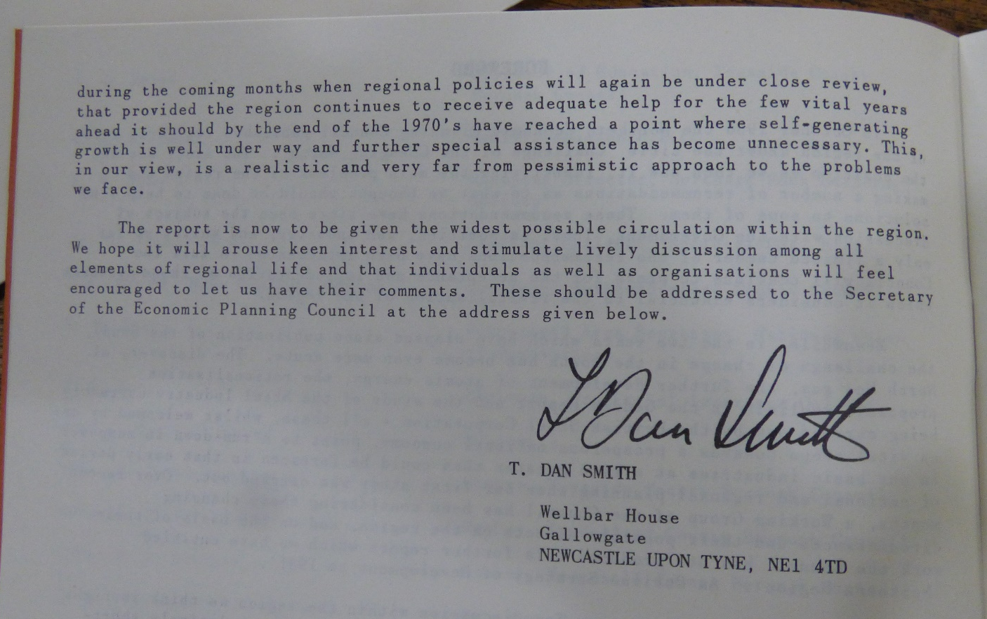
Description: Section of foreword to booklet which states Smith’s intention to circulate the document widely.

Source B2
Location: Tyne and Wear Archives, Discovery Museum, Newcastle-upon-Tyne
Title: Northern region: An Outline strategy of development to 1981
Reference Number: L/PA/1457
Date: 1969
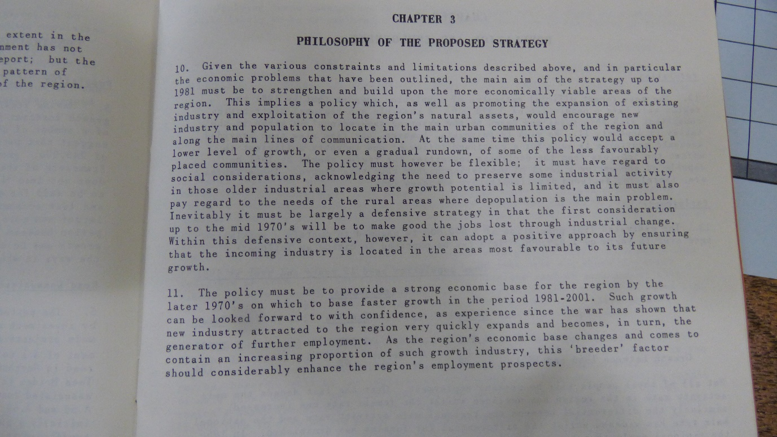
Description: Section booklet which outlines the overall philosophy of the NEPC’s plans.

Source B3
Location: Tyne and Wear Archives, Discovery Museum, Newcastle-upon-Tyne
Title: Northern region: An Outline strategy of development to 1981
Reference Number: L/PA/1457
Date: 1969
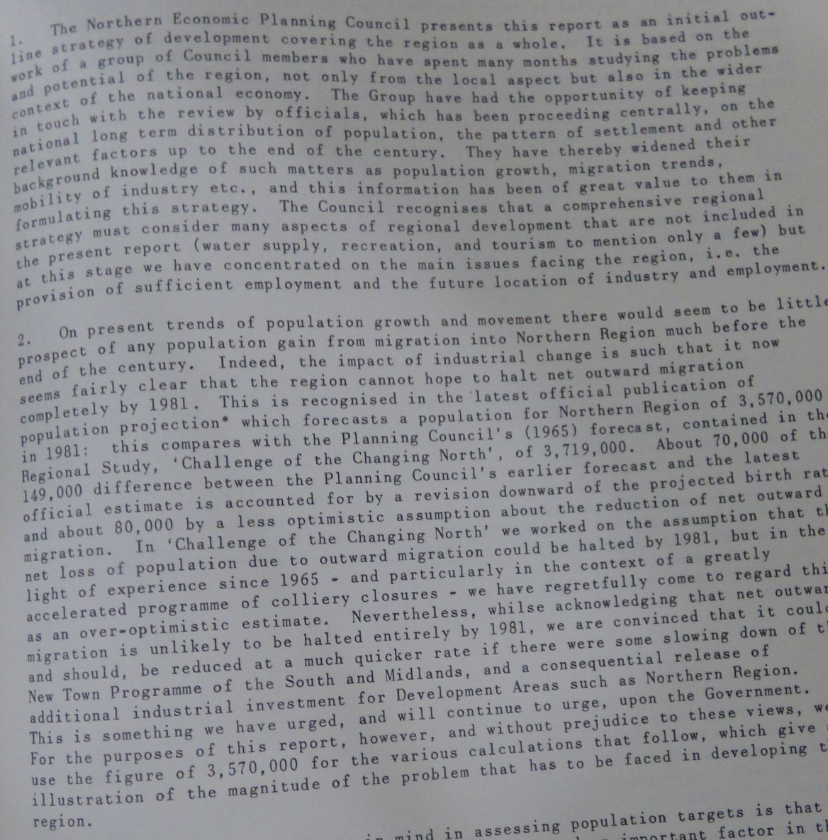
Description: Section booklet discussing population forecasts.

Source B4
Location: Tyne and Wear Archives, Discovery Museum, Newcastle-upon-Tyne
Title: Northern region: An Outline strategy of development to 1981
Reference Number: L/PA/1457
Date: 1969
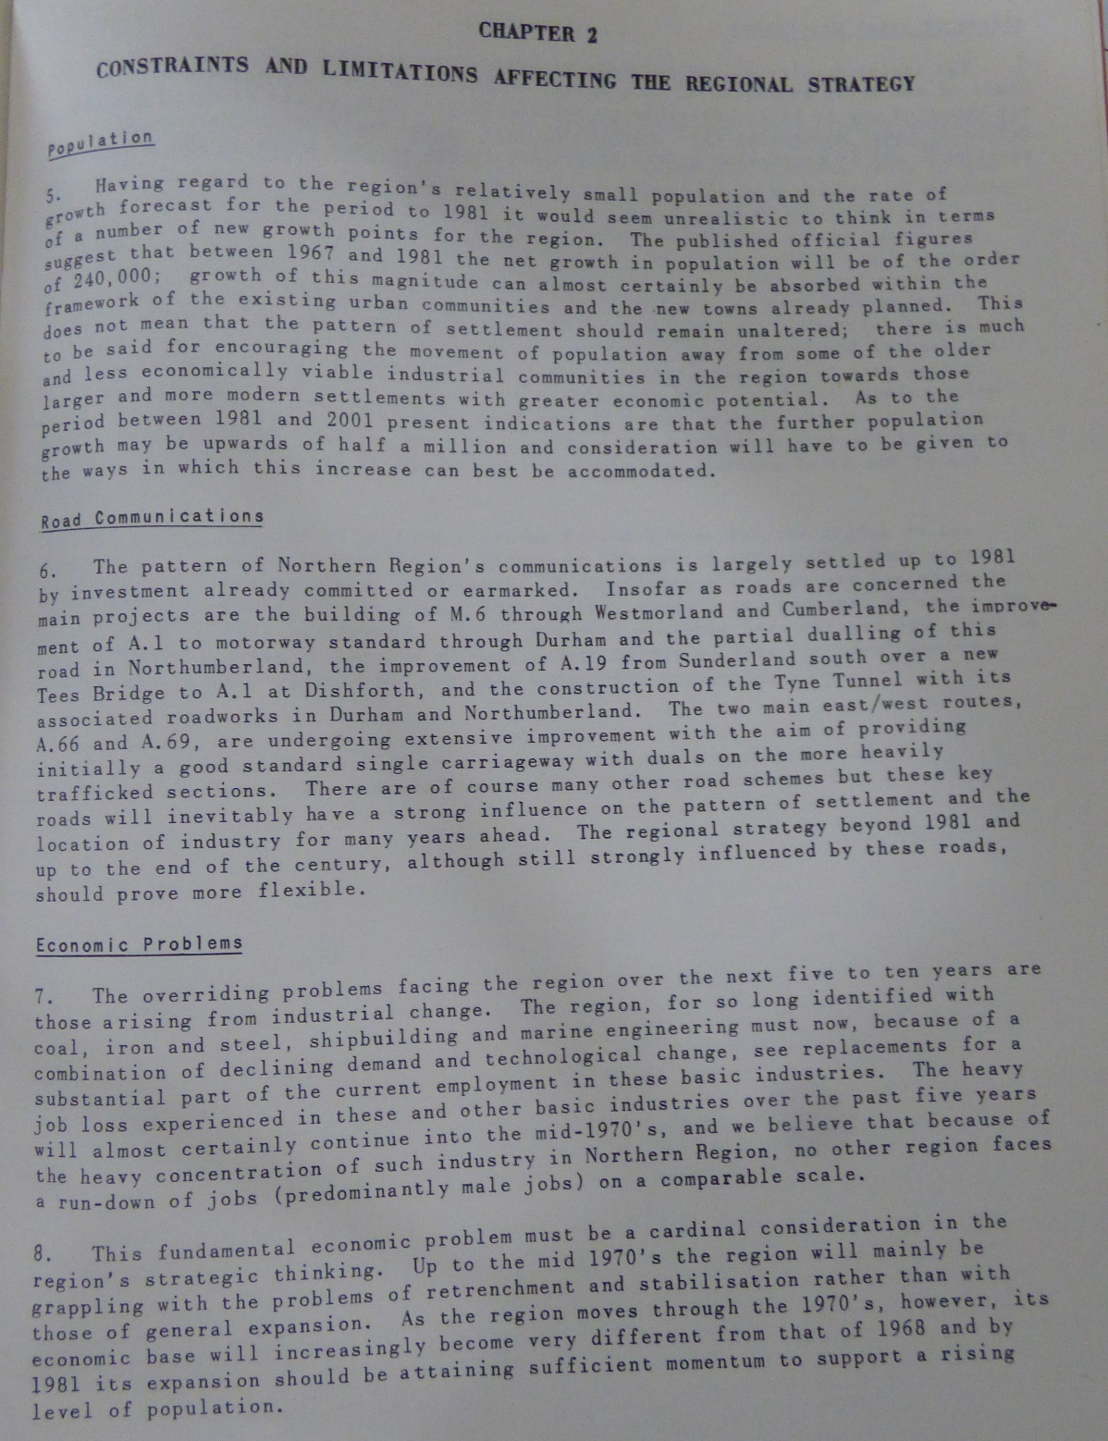
Description: Section booklet which outlines problems facing the region.

Source B5
Location: Tyne and Wear Archives, Discovery Museum, Newcastle-upon-Tyne
Title: Northern region: An Outline strategy of development to 1981
Reference Number: L/PA/1457
Date: 1969
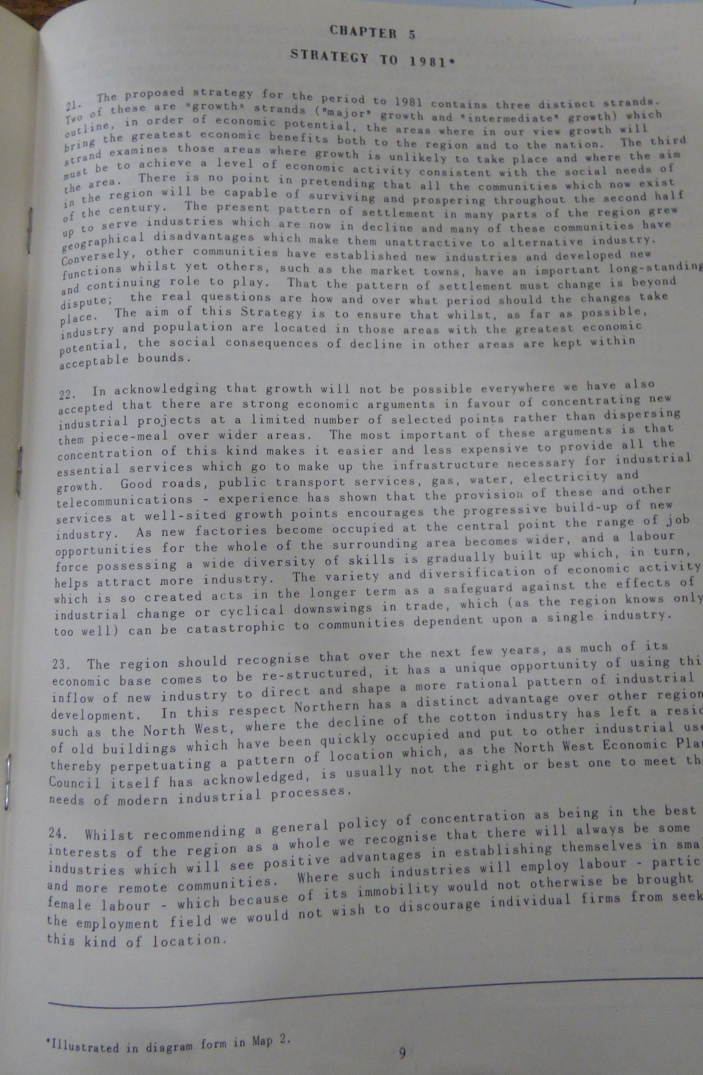
Description: Section booklet which outlines problems facing the region.

Source B6
Location: Tyne and Wear Archives, Discovery Museum, Newcastle-upon-Tyne
Title: Northern region: An Outline strategy of development to 1981
Reference Number: L/PA/1457
Date: 1969
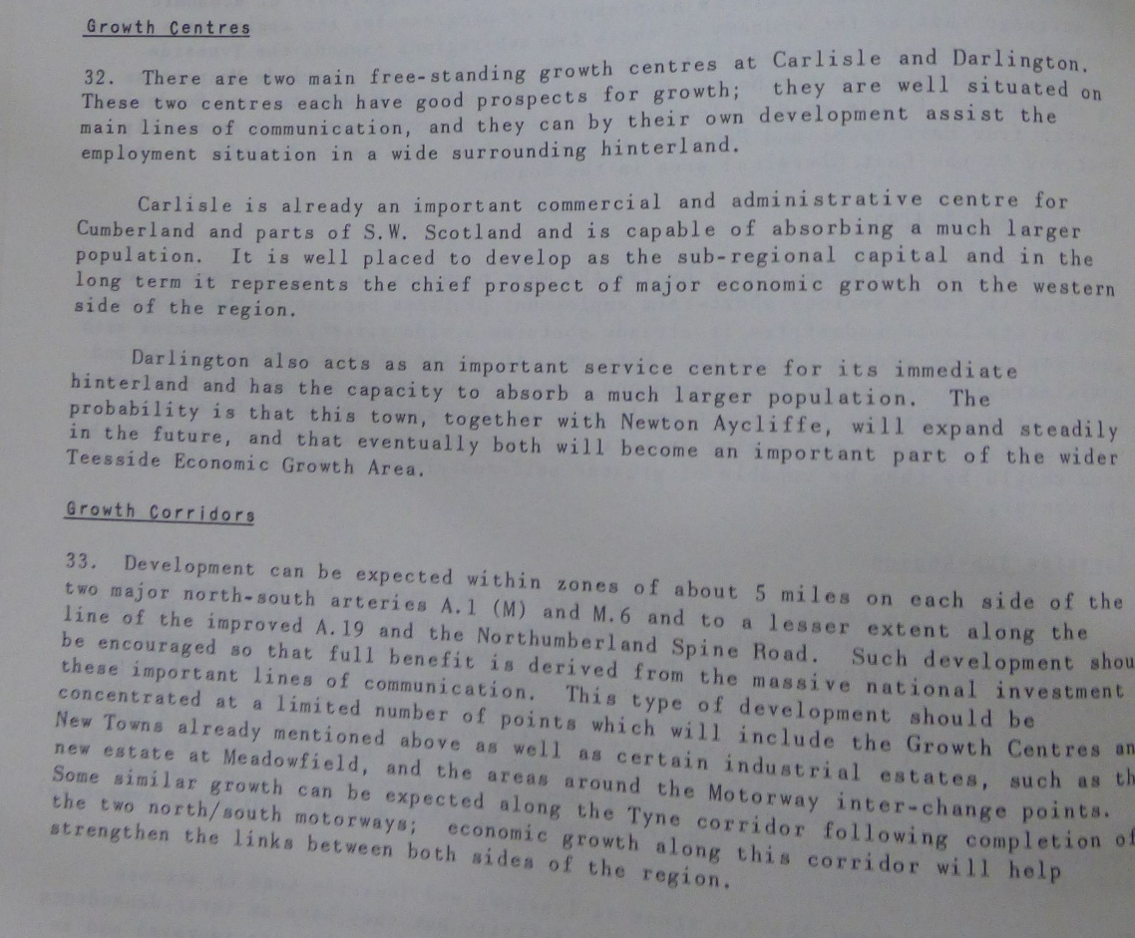
Description: Section booklet which explains areas designated for growth.

Source B7
Location: Tyne and Wear Archives, Discovery Museum, Newcastle-upon-Tyne
Title: Northern region: An Outline strategy of development to 1981
Reference Number: L/PA/1457
Date: 1969
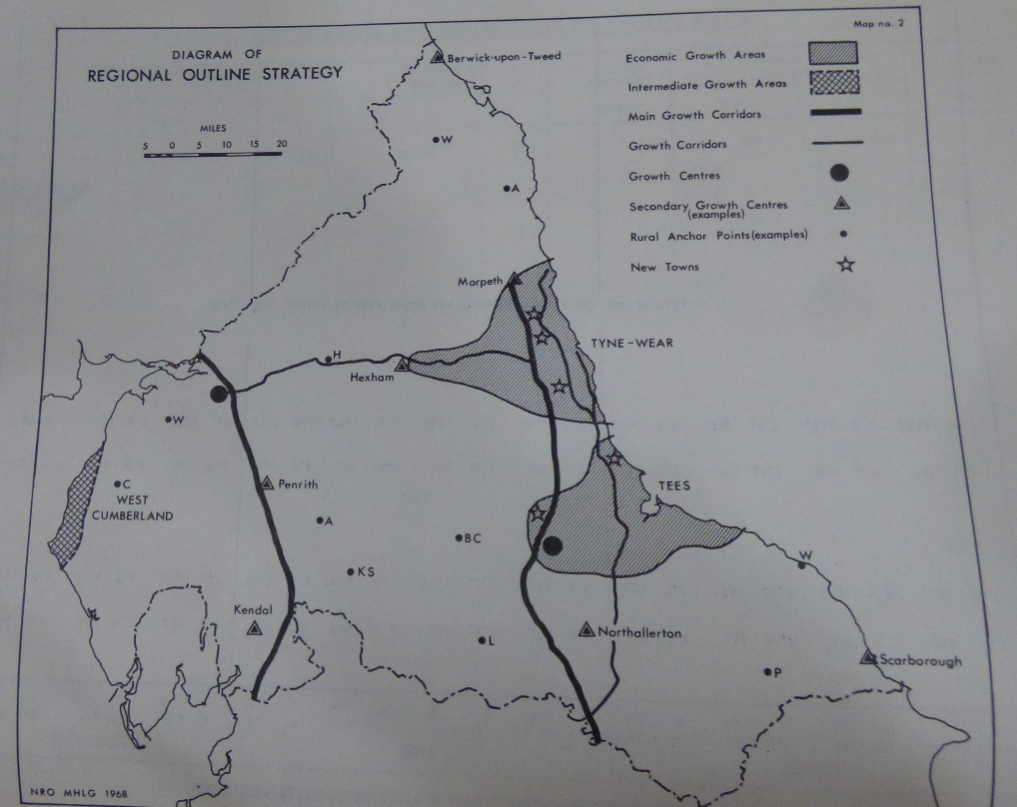
Description: Map showing proposed ‘growth corridors’ and ‘growth areas’.

Source C1
Location: Tyne and Wear Archives, Discovery Museum, Newcastle-upon-Tyne
Title: Northern region: An Outline strategy of development to 1981
Reference Number: DU.EB/60/7
Date: 1966
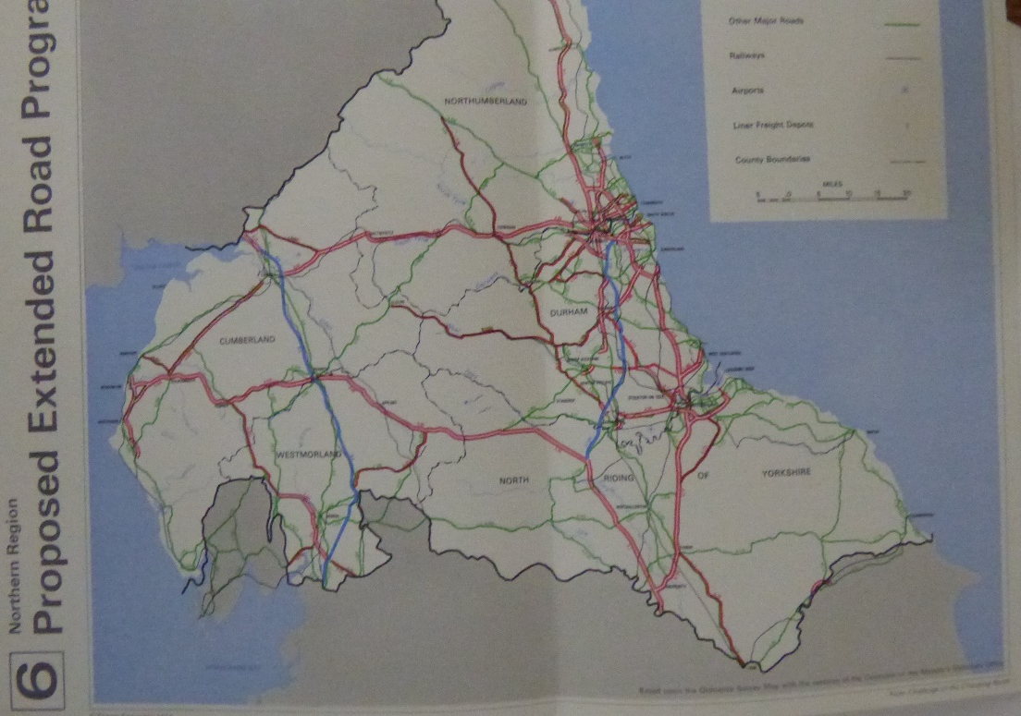
Description: Map showing proposed road extensions.

Source D1
Location: Newcastle Central Library
Title: A Funny Thing Happened on the Way to Utopia
Reference Number: 920 SMIT
Date: 1987
Description: Two journalists interview Smith and other key players, exploring and interrogating the story of the Trotskyists in Newcastle City Council, the claims of MI5 collusion, cover-up for cabinet ministers and the unseen role of the Privy Council as a power above parliament.

T. Dan Smith, A Funny Thing Happened on the Way to Utopia, film, directed by Elaine Drainville (Newcastle: Amber Films, 1987).
See source B1.
Steven Cotgrove, “Obituary: Henry Parris,” The Independent, March 2, 1996.
See source B3..
See source B4.
Mike Nally, T. Dan Smith, film, directed by John Mapplebeck (London: BBC, 1986).
A decision which is further explained in: Chris Foote Wood, T Dan Smith:"voice of the north" - downfall of a visionary: life of the north-east's most charismatic champion (County Durham: Northern Writers, 2010).
See source B5.
See source B2.
John Pendlebury, "Alas Smith and Burns? Conservation in Newcastle upon Tyne city centre 1959–68," Planning Perspectives 16 (2001): 115–141.
See source B6.
See sources B7 and C1.
See source B2.
See source A3.
See source A4.
See source A5.
Robert Waterhouse, "T. Dan Smith (Obituary)," The Guardian, July 28, 1993.
Unknown Author, "Powerbroker who fell from grace," The Financial Times, July 28, 1993.
See source A3.
See source D1. 77 minutes.
See source D1. 78 minutes.
Unknown Author, "The rise and fall of Mr Newcastle," The Journal, March 10, 2004.

